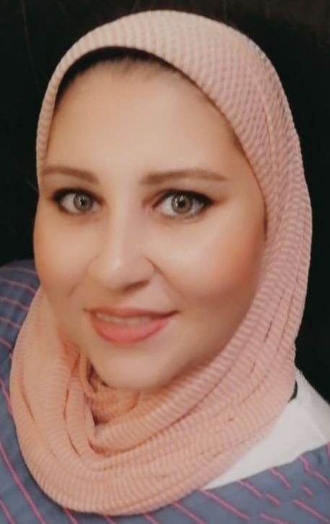 |  |  |  | Maha  Mohamed Ahmed Khalil

Experience
- Asala for natural cosmetics ( executive secretay + social media team)
From 1-2020 until now
- Asala for natural cosmetics ( executive secteray )
From 5-2002 to 2-2007
- Abdaa for real estate markting ( sales )
2 monthes
- Al shark al awst insurance ( sales)
6 monthes

Education
- High school
Lycee la libertee
Graduate in 1997
University
- University of accounting
2001
Managmement ana accounting divion
4th degree :Good

Communication
- Computer skills good in:-
- Microsoft office (Word – excel – access point…..)
- Language :-
- Good command of English language
- Fair photoshop skills
- Well organized
- Have the abilty to work under pressure
- Have the spirt of team work
- Fast learner
- Good communication skills
- Problem solving
Hobbies
Art – Music –Travelling
References
Available until request
 |  | 4 el barawi sidi gaber
 |  | 01091630829
 |  | Mahamohamedahmedkhalil@gmail.com

