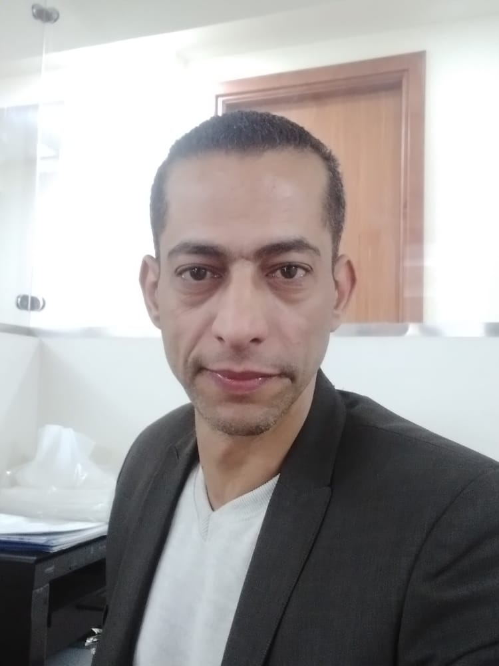

**Safwat Elshater**

**Job Objective:**

**Seeking a fulfilling position in which I can achieve my skills as I’m always looking for an opportunity to grow professionally and learn new skills.**

**High work efficiency and responsibility, creativity in problem solving, ability to lead a team and people oriented.**

**Personal information**

**Full name: Safwat Elsayed Mahmoud Elshater**

**Date of Birth: 09/02/1979**

**Nationality: Egyptian**

**Height/Weight Cm/Kg: 173/73**

**Address 3 Elmadrsa Street, Zokak Elkaser, Cairo, Egypt**

**Telephone: 010-037-67-410**

**Martial Statues: married**

**Email:** [**safwatcairo@gmail.com**](mailto:safwatcairo@gmail.com)

**Email: safwatelshater@gmail.com**

**Education**

**Tourism and Hotels**

**Language skills**

**Arabic: Native language**

**English: Fluent Spoken and written**

**Russian and German: Basic**

**Work Experience**

* **From 27 – 7 – 2021 Till Now in Nasr City Hospital**

**As a Health and Safety Manager**

* **From 20 – 3 – 2020 Till 20 – 7 – 2021 Albaqyat AlSale7atAssociation**

**As a Health and Safety Manager**

* **From 15 – 1 – 2019 Till 12-1 - 2020 In ElMasa Capital Hotel in new Capital**

**As a Health and Safety Senior Administrator**

* **From 01 – 04 – 2018 Till 01 - 05 - 2018 In Artoc Auto**

**As a Health and Safety Administrator**

* **From 1 – 11 – 2017 Till 1- 3 - 2018 In Cone for Elevator New Cairo**

**As a Health and Safety Inspector**

* **From 18 – 11 – 2016 Till 1- 10- 2017 In Mirage Mall New Cairo**

**As a Health and Safety Manager**

* **From 10-5-2015 Till1 1- 8- 2015 in Mena House Hotel Giza**

**As a Health and Safety General Supervisor and Departmental trainer**

* **From 1-10-2014 Till 1-2-2015 in Sun city Mall Cairo**

**As a Health and Safety General Supervisor and Departmental trainer**

* **From 10-12-2007 Till 1-8-2014 in Holiday inn Cairo city stars Hotel**

**As a Health and Safety Supervisor and Departmental Trainer**

**Training and Qualifications**

* **Comprehensive Quality Management and Modern Trends in Hospitals 2022**
* **Medical Waste Management Faculty of Medicine Qasr Al Aini 2022**
* **Osha Academy Training Construction 2012**
* **Osha Academy Training General 2012**
* **Departmental Trainer for Health and Safety {IHG} Intercontinental Hotel**
* **Risk management {IHG} Intercontinental Hotel Group**
* **Management Skills {IHG} Intercontinental Hotel Group**
* **Committee members Basically 2017 National Center for the Study of**

**Occupational Safety and Health**

* **Edward System Fire Alarm Panel**
* **Apollo System Fire Alarm Panel**
* **Simplex Gas System Panel**
* **Ansul kitchen hood fire Suppression Systems**
* **Group Training Certificate (GTC) In {IHG} Intercontinental Hotel Group**
* **Craft Training Certificate (CTC) In {IHG} Intercontinental Hotel Group**
* **Health and Safety Red Sea Documented**
* **Health and Safety Member Red Sea Hurghada**
* **Health and Safety Community Member Red Sea Hurghada**
* **First Aid Courses 2005 Egyptian Red Crescent**
* **First Aid Courses 2008 Egyptian Red Crescent**
* **First Aid Courses 2014 Egyptian Red Crescent**
* **Civil Defense**
* **Experience in Dealing with Government Offices (Occupational Safety and**
* **Experience in the preparation of reports daily and monthly statistics,**
* **Of Occupational accidents, occupational diseases record.... Etc.**
* **Have The Ability to Communicate with Different Levels of Management**

**Personal Strengths**

* **Energetic, hardworking and conscientious**
* **Competent, effective and productive**
* **Trustworthy, punctual and reliable**
* **Willing to learn and accept responsibilities**
* **Creative, innovative and supportive**
* **Cooperative, dependable and supportive**

**Employment Strengths**

* **Display appositive and enthusiastic attitude**
* **Committed to high standers of customer service**
* **Can accurately follow oral and written instructions**
* **Work quickly and make good use of time**
* **Contribute effectively in a team environment**
* **Pay attention to details, order and neatness**
* **Respond well to high pressure situation**
* **I Can handle multiple tasks and responsibilities**
* **Show a disciplined and safe approach**

**Hobbies and interests**

**Sports /Fitness (kung Fu, Football Body building, table tennis, Etc.)**

**Reading, browsing the internet, music**

**Computer skills**

**Good command of windows XP, seven, 8, internet, Microsoft Package)**

**Reference**

**Eng. Mena Gorges**

**Chef Engineer**

**Tel No, 202 0122-155-3300**

**Eng. Mohamed ElBihedy**

**Health and Safety Manager. Fairmont Nile City Hotel**

**Tel No, 202-0120-289-9217**