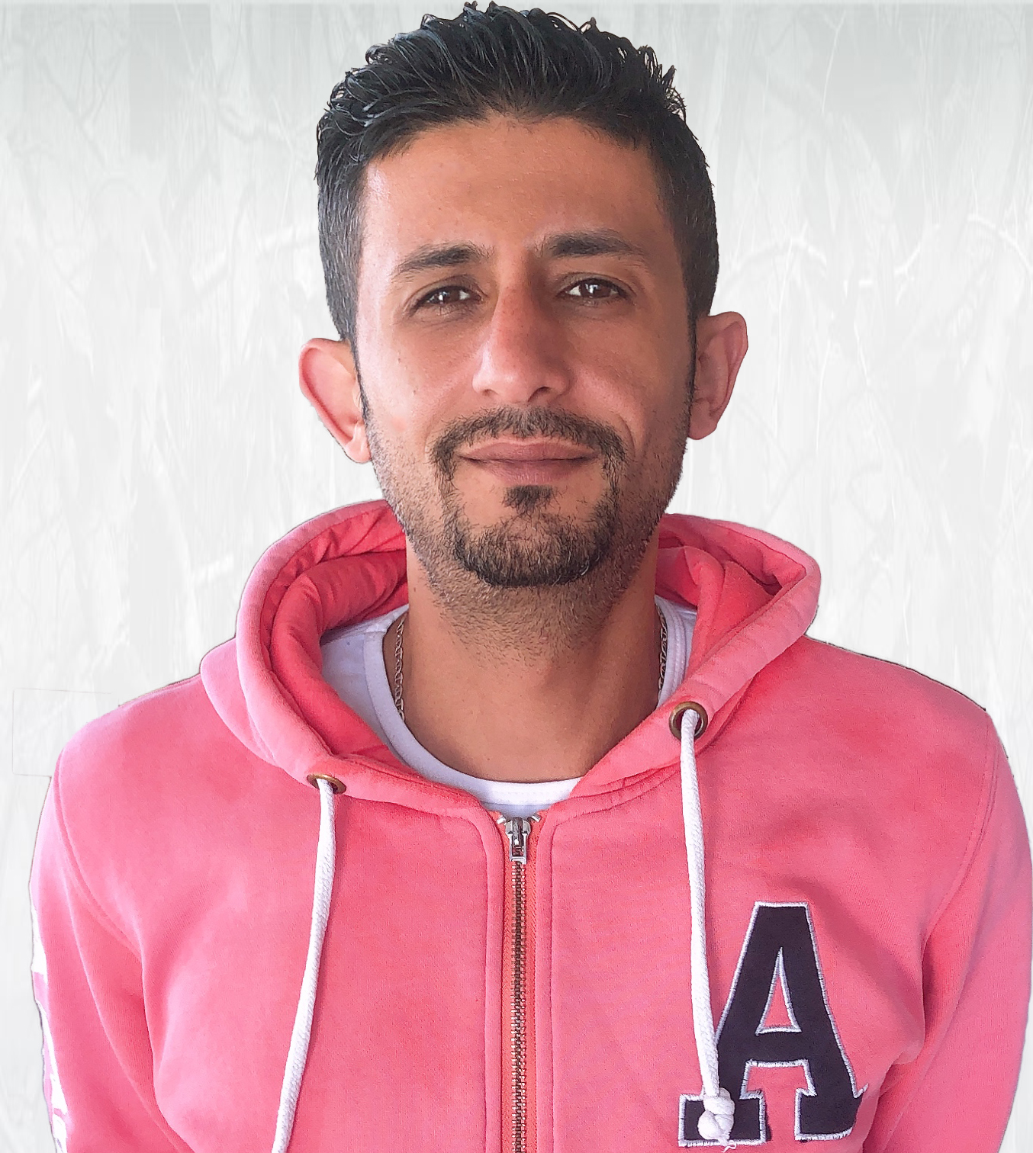 |  | Mohamed ibrahim
personal info  Bithdate: 15/02/1993  Location: Alex, Egypt  Military statuse: Exempt  Marital statuse : Single  Contact  PHONE:  +20-1224-135529  +20-1032-715620  EMAIL:  Mibrahimalexapparels@gmail.com  languages  Arabic: Mother tongue  English: Good “Speak, Read& write”  Hobbies  Cycling  Music  Hang out |  | EDUCATION  Alexandria University, Faculty of sciences, Computer department  June 2005  Bachelor of Computer science with Good degree.  WORK EXPERIENCE  Human Resource (6/2008: Present)  ALEX Apparels Group  Seles man (3/2007: 4/2008)  Jewelry store  certificates  - HR (خلال المده من 4/2008 حتي 6/2008 )  - English ( ABC خلال المده من 6/2010 حتي 8/2010 في سنتر)  - Fire Fighting (خلال المده من 10/2010 في هيئة الدفاع المدني)

