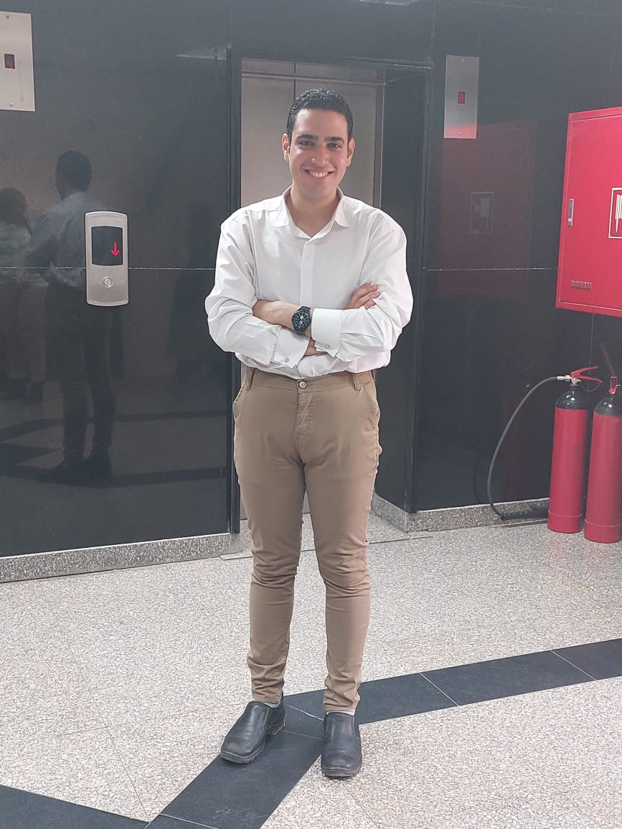**Fady Refat Paules Abdel shahed**

**Personal information**

**Address: 5st Mohamed Kamal street El Haram, Giza , Egypt.**

**Tele: +2 012 10334182**

**Email: fadypoles2@gmail.com**

**Date of birth: 27 June 2000**

**Marital status :Single**

**Nationality: Egyptian**

**Military status: Exemption**

**Education:**

**Graduated from Faculty of Mass Communication, Cairo University, Public Relations and Advertising Department, with excellent grade, And Excellent grade in my graduation project. May 2022**

**Internships and Training**

**-Trained public relations, at the State Information Service in 2021**

**-Soft skills courses with vois and smart company**

**- Trained in banking sector in abk bank**

**work Experiences**

**-I have experience in the field of reception, as I worked as a receptionist at Saint Demiana Hospital in Haram during my summer vacation from studying.**

**-I worked as a call center at Banque Misr on November 2022, and left work on April 2023. My duties were to respond to customers' inquiries about the bank's products and services, solve any problem they encountered, maintain the bank's reputation, and strive to obtain customer satisfaction and loyalty.**

**-I worked as a data entry in the Eva company in July 2022 and left work in October 2022, and my duties were to record customer orders on the company’s system and send them to the marketing managers**

**-I worked as hr in Al-Takamul Company for Recruiting Workers Abroad from June 2023 to October 2023 . My responsibilities were to post job advertisements on various platforms, review applicants’ CVs, and contact them if the applicant was suitable for the conditions and experience required by the employer.**

**-I am working now as a call center in eg bank from November 2023**

**Language Skills**

**Arabic: Native language**

**English: very good speaking, reading and writing.**

**Soft skills**

**Negotiation skills**

**Presentation skills**

**Creative Thinking**

**Marketing Team work and leading**

**Problem solving and Advertising reputation of the company**

**Preserving the identity and**

**Computer Skills**

**Skilled in the usage of (Word , PowerPoint and excel ) . Surfing the internet.**