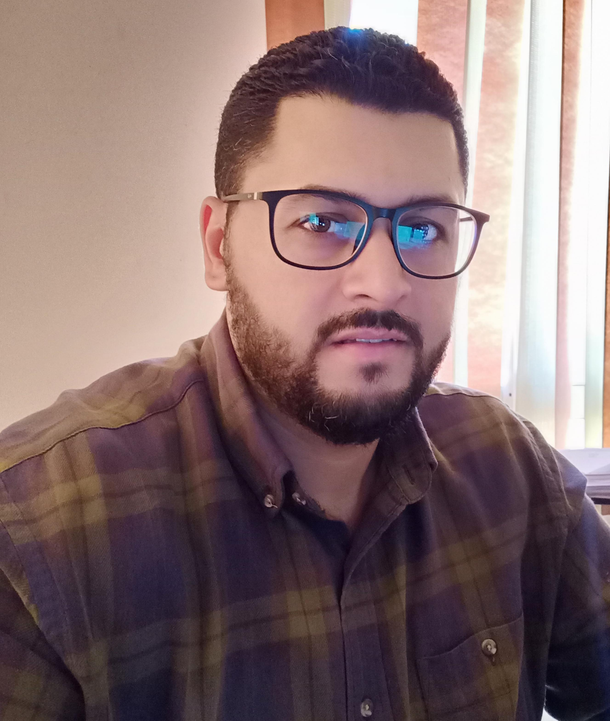 |  |  | Ayman Abd ElAziz  Senior Surveyor
Profile  Senior Surveyor with experience and good knowledge in architecture and civil works, tanning, lead team and time management, accumulative experience through several projects. Skilled at learning new concepts and techniques, working well under pressure and communicating ideas clearly and effectively.  Contact  PHONE:  +201113203997  +201062121566  EMAIL:  aymanaptyegypt@yahoo.com ayman.apty.9@gmail.com  Personal Information  Date of birth:  10/05/1981.  Nationality:  Egyptian.  Marital Status:  Married.  Total Station (Leica, Topcon, Pentax, Sokkia).  Languages  Arabic  English |  | EDUCATION  Survey Institute in Al harm, Egypt.  1998 – 2001  Technical Diploma in Surveying  SITE WORKS  Supervisor of Surveying work: -  * Building – MAILs – CLUB House  * Roads & Water & Sewage network  WORK EXPERIENCE  sites international, Cairo, Egypt (Senior surveyor )  Nov. 2020–Present  - Checking the Data from the Contractors, Shop Drawings,  Observations Taken in Site, and Generating Progress Charts for All the  Work Done in Site, Land scape Workings for many projects including.  Project:  - Hayd Park New Cairo  AMG Al Amar Consulting Group, Cairo. Egypt (Consultant senior Surveyor)  Nov. 2015– July 2020  - Checking the Data from the Contractors, Shop Drawings, Observations Taken in Site, and Generating Progress Charts for All the Work Done in Site, Infra Structure Workings for many projects including.  Project:  - compound AVARIS project (new Cairo): Contains 64 block of flats & 11T Transformers & Infra Structure and roads owner for project URC  EGEC Consulting, Cairo, Egypt (Consultant senior Surveyor)  April 2015– Oct. 2015  - Supervising the spatial work of the sewage network.  Projects:  - Shubra Al Khaimah - Bahtim – Bejam.  Mahmudiya General Contracting and Real Estate Investments, Cairo, Egypt (Surveyor)  jan. 2010- Dec 2014  Projects:  - Fire station at Cairo Air Airport.  - Construction of a wall, warehouses, observation towers and a  mosque for Asyut cement factory in Asyut City *Construction of  wall, warehouses, observation towers and a mosque for Asyut  - cement factory in Asyut City.  CEE - Cairo Engineering Equipment Cairo, Egypt. (Surveyor )  From 2009 to 2010.  Projects:  - Spatial work to sign a guidance board on the airstrip of Cairo  Airport.  Enco, Cairo, Egypt.(Surveyor )  From 2008 to 2009.  Projects:  - Surveying works (in the Village of Gold Coast) in  Sharm el Sheikh  Jet - Egyptian Company for Trading & Engineering  Jan 2007 to Dec 2008  Projects:  - Construction of the Building (Darra Garden) in the City 6 of  October.  Elsewedy Electric co. in Cairo and Khartoum, Sudan.(Surveyor )  May 2005 to May 2006,  Projects:  - Spatial work to plan low voltage current connection poles.  - Khartoum city and Um Dorman, Sudan.  - The city of Maraway, Dabba and Donicola (Northern State of  Sudan)  Arab Contractors Company, Cairo, Egypt (Surveyor )  Nov 2001 – May 2005  Projects:  - ELbahr El Aazam Street in Giza.  - Replacement and renovation of The Pyramid Street in Giza  - Replacement and renovation of Lebanon Square in Giza.  - Replacement and renovation of the Giza Fishing Club Field.  - Replacement and renovation of Johaina Square in the City of  6 October.  - Internal road for Beverly Hills, 6 of October.  - Maintenance of the Axis Road 6 October.  - Construction of the South Dahshur International Road.  Organizational / managerial skills  - Good organizational skills gained as Coordinator and team leader  through projects.  - Motivational Skills  - Hard working character  -Mentoring skills  -Good command of quality control processes

