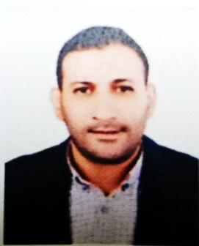**Curriculum Vitae**

**Ahmed Abdel Moez Mohamed Tantawy**

**Address: 63 Saad Al-Janaini Street - Al-Saada City - Al-Matareya - Cairo Mobile number: 01125152372**

**Target:**

Getting a job suitable for my abilities in your esteemed company

**Personal data:**

**Date of birth: 21/7/1985**

**Marital Status: Married (I count 3 children )**

**Nationality: Egyptian**

**Place of birth: Cairo**

**Attitude to conscription: final exemption**

**Qualification:**

Above-average qualification (Abbasiya Institute for Computers and (Commercial Sciences) grade (good)

**Year of Graduation: 2007**

**Skills:**

**computer skills:**

Proficiency in dealing with Office programs, Windows and the Internet

**Language skills:**

Arabic: the mother tongue

**English: Intermediate**

**Personal skills:**

Ability to work under pressure

Ability to work in a team

Proficiency in communication skills

**Of experience:**

* Receptionist job at the British Hospital Shorouk - Madinaty from 12/1/2022 to 8/30/2023

* Administrative coordinator job at High Lightmedia Production Company from 9/1/2021 to 11/15/2022

* Operation supervisor in the administrative buildings of Madinaty Company (Talaat Moustafa Group) from 1/2015: 10/8/2021.

* Purchasing representative in Al-Rehab Management Company (Talaat Moustafa Group) from 1/2012: 12/2014

* Reception employee at the medical center in Al-Rehab Management Company (Talaat Moustafa Group) from 2008: 12/2011