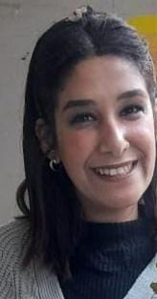**Verounica emad wahby bishara**

Address : 24 ah-tag street , al-teraa al-bolaqia , shobra , Egypt

Email : [verruemad90@gmail.com](mailto:verruemad90@gmail.com)

Phone : 01208502262

Objective :

Seeking to join your company where my studies and capabilities can be fully utilized and developed.

Personal data :

Place of birth : cairo

Nationality : Egyptian

Date of birth : 15/8/1997

Marital status : single

Graduation year : 2020

Education :

Faculty of al alsun , Hebrew department – in ain shams university , bca alsun

Grade : good

Graduation project grade : very good

Languages :

Native language : Arabic

Good in English and Hebrew and jerman

Experience :

I have a little experience in call center in Vodafone and in irregular employment company.

I have more experience in social media in art hand academy , employment offices and secrtary.

I Worked in 4 nurseries ( The virgin mary with the face , the apostolic grace , the faith and the future nursery ).

I worked at al-shams company as a sales department and I have a little experience in telesales.

Now I am currently working as a secretary at art hand academy.

Computer skills & courses :

Microsoft office ( word , excel , power point )

Self – motivated & quick learner

Good communication and negotiation skills

Leadership skills

Sociable and adapts to the environment.

I'am available to learn more .