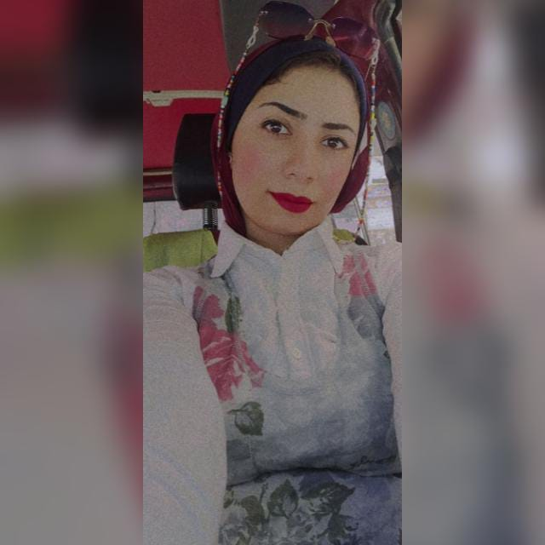

EMAN KHALED

***Memok3097@gmail.Com***

Personal information

**Name: Eman Khaled Mahmud Ahmed**

**Birth date: 16/1/1996**

**Address: Teto St. Al hwamdya-Giza**

**Phone number: 01158454703**

**Citizenship: Egyptian**

**Marital Status: Single**

Personal Summary

* **A critical thinker with strong analytical skills**
* **Good organizational skills developed in a variety of deadline orientated situations.**
* **Have good presentation skills combining sound analytical research and clear verbal explanation.**
* **Seek out new responsibilities irrespective of reward and recognition.**
* **Strive for quality in everything I do.**

Education

**Bachelor's degree in Arabic Language, Faculty of Dar Al Uloom (2018)**

Work Experience

* **Adam laboratory for medical analysis**
* **Administrator in an accounting office**
* **Student Affairs at Future Generation Language School.**
* **Student Affairs at Future Integrated Language School**.
* **Teacher at kindergarten language**

Language

* **Arabic is the native language.**
* **English is very good written and spoken.**

Computer Skills

* **Microsoft Office programs.**

Activities

* **Reading books and articles.**
* **Swimming.**
* **Travelling and camping.**