Esraa Mostafa Abd-elmonem

Address: Ahmed Saeed street building 12 abasia . Egypt

Phone number: +2 01120527059

[Email: esraa.mostafa2000 @g](mailto:eman-rashwan@cu.edu.eg)mail.com

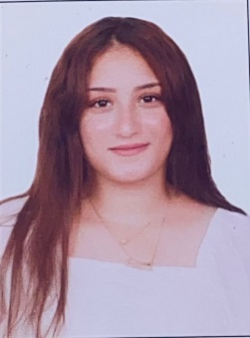

**Personal Data:**

Date of birth: 29/ 12 / 2000

Place of birth: Cairo, Egypt

Nationality: Egyptian

Religion: Muslim. Marital

Status: Single

**Objectives:**

To contribute to the success and growth of a multinational or international organization with my education and academic experience develop my skills towards what is better.   
Looking for both personal and professional growth makes me capable of working confidently  
under pressure. Being bilingual gives me the chance to function efficiently in both English and Arabic. My background and growing up experience have given me a deep insight in the culture and society together with a wider scope in the world of business.

**Education:**

**License degree** from faculty of law, Arabic section, Ain-Shams university (2022)

**Grade:** Good

**Courses:** - ICDL certificate - Multi Computer user

**Professional Experience:**

Secretary at an Elmahdy office from January 2019 to December 2020

Training at Mohamed Ibrahim law office from January 2020 to November 2021

Secretary at Mohamed Badr Medical center from December 2021 to September 2023

**Personal Skills:**

Accurate, Careful, precise and sharp eye for details

Ambitious: Full of ambition, strong desire (to do) something challenging and willing to learn

Energetic: Active, full of live, vigorous, an energetic worker

Flexible: Manageable and adaptable to the new surroundings

Hardworking: Eager to prove my skills and myself and have the ability to handle pressure and meet deadlines with high efficiency

Responsible: Capable of rational conduct, trustworthy with current objectives and has leadership skills.

**Computer Skills:**

Professional command of Microsoft Word, Excel, and PowerPoint

**Language Skills:**

Arabic: Native (Mother tongue)

English: Good