**C.V**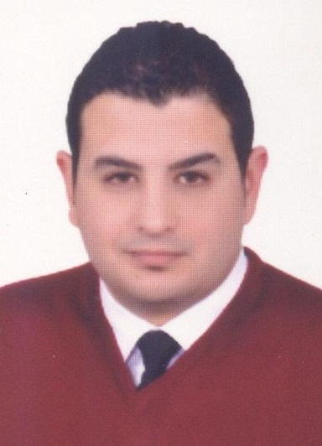

**Name: Ahmed Saeid ElSayed.**

**Address - EllBitash - Alexandria - Egypt**

**Mobile: 01285845074**

**E-mail /** [**egy_man1000@yahoo.com**](mailto:a_said14@hotmail.com)

**ـــــــــــــــــــــــــــــــــــــــــــــــــــــــــــــــــــــــــــــــــــــــــــــــــــــــــــــــــــــــــــــــــــــــــــــــــــــــــــــــــــــــــــــــــــــــــــــــــــــــــــــــــــــــــــــــ**

**Personnel Data :**

**Nationality : Egyptian .**

**Date of Birth : 6/8/1985 .**

**Marital Status : Married.**

**Military Service : Exemption** .

**Professional Experiences :**

**1- Jinet Landscape and Services As Senior HR Coordinator From 04/11/2020 Till Now .**

**2. Alex City Mall Human recourses As HR Manager from 01/11/2018 Till 01/04/2020**

**3. Sarai Market Human recourses As HR Manager from 20/05/2018 Till 30/10/2018.**

**4. Economic Group For Project Management Human recourses As Assistant HR Manager from 03/11/2011 Till 28 /04 / 2018 .**

**5. Administrative Officer of Al Ahram Printing and Publishing.**

**6. Alexandria Company for Office Equipment As Marketing representative.**

**Education:**

**Alexandria University Bachelor of Arts (Department of Philosophy).**

**Graduated Year May 2007.**

**Language:**

1. **Arabic : Mother Tongue.**
2. **English : Read, Write .**

**Computer Skills:**

1. **All Windows & All Office from 98 to 2010.**
2. **Human Resources & Payroll System.**

**Training:**

1. **Human resources course ( HRC ) 2010 .**
2. **Fire Fighting & Evacuation .**

**Other skills:**

**-Hard working .**

**-Capability to work under pressure .**

**-Active .**

**-Ambitious .**

**-Decision maker .**

**-High ability in solving problem .**

**HOPE ALL ABOVE CORRESPOND TO YOUR**

**EXPECTATIONS.**