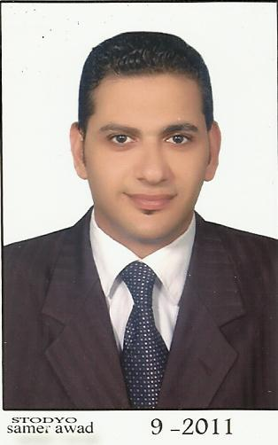

**Ahmed Mustafa El Said El-Banna**

**Email**: ahmed.elbanna2011@gmail.com  
**Age**: 29**date of birth**: 1/4/1985

**Marital Status**: Single

**Nationality**: Egyptian

**Religion**: Muslim

**Military Records:**Finished

**Private driving license:** from 2006 to 2016

**Address**: 6 Batal El Salam st. El Raml. Alexandria, Egypt

**Cell Phone:** +2 01000400676 / +2 01210602020

**Objective**

Testing of new systems and services, providing quality solutions to complex business problems and delivering, to manage people, interface with customers, and work with highly technical software or hardware applications, Looking for a job that give me a change to develop my skills and to be apart of an active society where I can build my public relations, Communications and Skills

**Professional Experience**

***-* United Group Co. For Engineering & Construction from** 7/2006 **to** 8/2007

**- Barclays Bank (sales representive in lone department) from** 8/2007 **to** 10/2008

**-NM technology. For internet Solutions. (Salesrepresentive) from** 10/2008 **to** 3/2010

**- Allianz Egypt . . (Salesrepresentive) from** 4/2010 **to** 8/2010

**-Q.Vision For internet Solutions (sales representive) from** 9/2010 **to** 2/2011

**-Sky Alex for marine service company . (Marketing) from** 6/2011 **to** 5/2012

**-GABL Group For internet Solutions . (Marketing) from** 8/2012 **to** 3/2013

**- Napura Egypt For hair care division (sales representive) in Alex branch from**4/ 2013 **to 8/2014**

**-Soskin Egypt for skin care (supervisor) ) in Alex branch from** 9/ 2014 **till naw**

**Education**

**- University:** Bachelor of literary studies, people contact and Media **2005-2006**

**-** **Graduated** **in** **High School****(**Elnasrya school**)**  **2001-2002**

**Skills Summary**

**Languages** - Language: Arabic, The level of talk: **Excellent**, Writing standards: **Excellent**, Reading level: **Excellent**.

- **Languages** - Language: English, The level of talk: **good**, Writing standards: **good**, Reading level: **good**.

**Capabilities** - The ability to **work under pressure** and ability to bear the additional burden and skills in dealing with the computer , Ability to work well with levels of management, Ability to learn new tasks quickly , Very good communication skills ,

**Flexible in learning new techniques** ,

**Capable of working with a team ,**

**Excellent problem solving skills.**

**Computer skills** - Good knowledge of windows Good knowledge of Excel,Internet, and Word