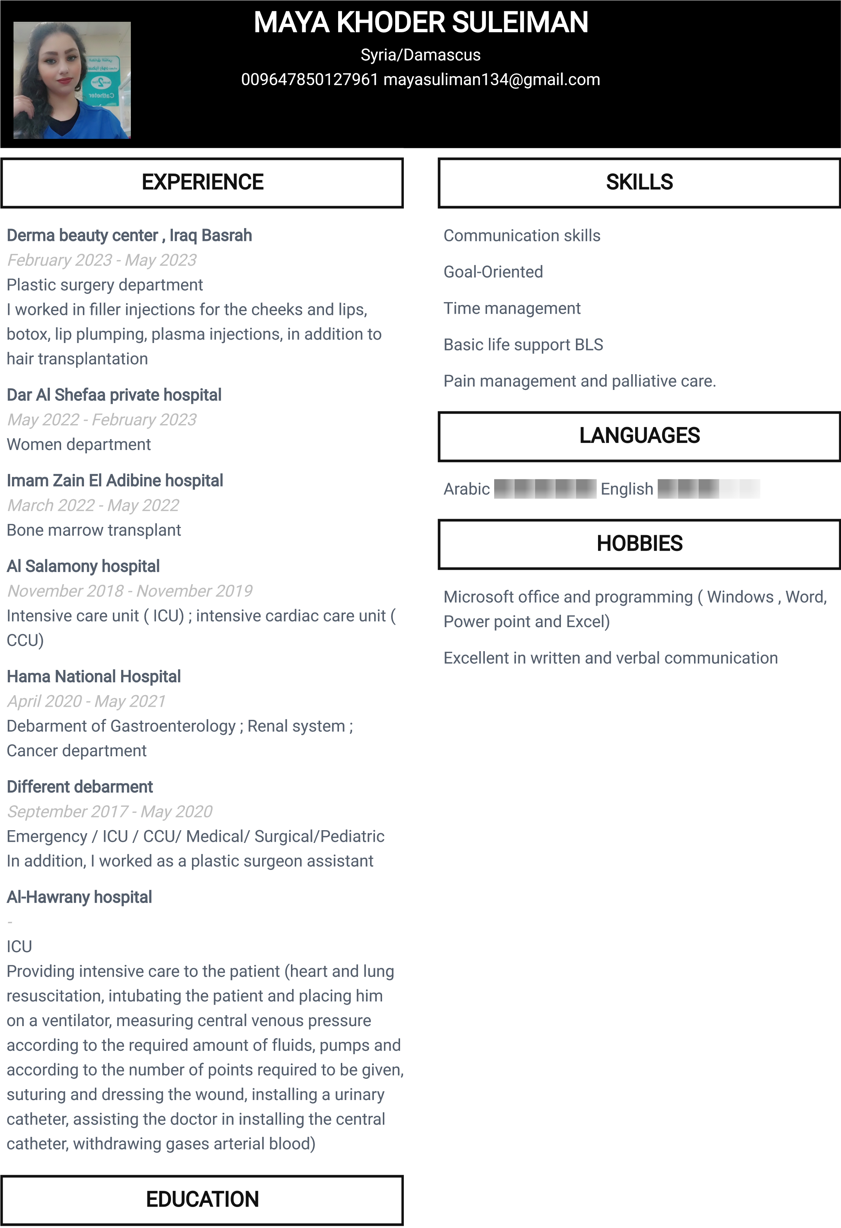

Baarin public school ( Salim al Afsaa)

August 2016

Nursing school hama , July 2020

SUMMARY

Seeking for job while maximizing my nursing skills and being a positive influence on hospital. Bringing experience , care , and extensive knowledge to help improve the lives of patients

MARITAL STATUS

Single