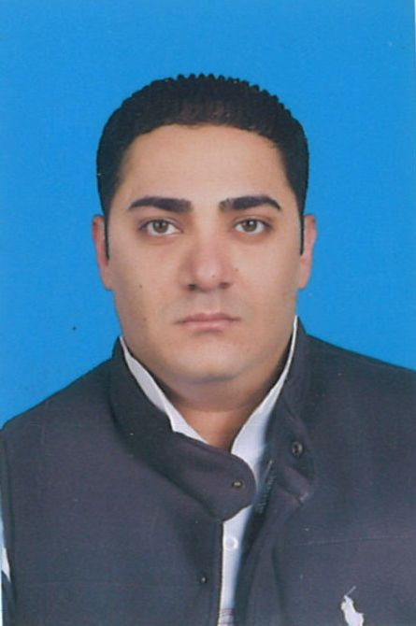**RAMEZ MAGDY AYAD**

Cellphone #: 01276726621

01025872595  
Address: Assiut, Al-Hamra District,

Al-Minshawy Street, Building 18, Floor 3  
Passport #:A12667160  
Expired: 25/06/2021  
E-mail: [ramez_magdy81@yahoo.com](mailto:ramez_magdy81@yahoo.com)

**OBJECTIVES**

* To obtain a position that will enable me to use my organizational background and ability to work well with other people
* Seeking a position in an organization where my knowledge will be updated and my skills be utilized

**QUALIFICATION**

* Good listening and interpersonal skills focused on teamwork and professional working
* Manage time effectively while performing multiple tasks under time pressure
* Ability to work unsupervised

**PERSONAL DATA**

Nationality : Egyptian  
Gender : Male  
Date of Birth : November 20, 1987  
Age : 35  
Civil Status : Married  
Religion : Christian

**WORKING EXPERIENCE**

Jun 11. 2016 to Until now M H Alshaya.co

BABL (Kuwait)

Position Bartender

April 24, 2013 to June 10, 2016 KOUT FOOD GROUP  
 Burger King (Kuwait)   
  
Position Delivery Driver and  
 Part Time as a Team Member

Mar 2012 to Mar 2013 Oscar company for general trading

And contracting

Position sales Representative

October 2010 to February 2012 AL SAFAT UNITED FOOD  
 COMPANY  
 Don Mario’s Restaurant  
  
Position Captain

August 2009 to September 2010 AL SAFAT UNITED FOOD  
 COMPANY  
 Afendim Restaurant   
  
Position Captain

April 2009 to July 2009 AL SAFAT UNITED FOOD  
 COMPANY  
 Al Sanawber Restaurant  
  
Position Waiter  
  
April 2010 AL SAFAT UNITED FOOD  
 COMPANY  
 Afendim Restaurant  
  
Position Waiter

**EDUCATIONAL BACKGROUND**

**2006  
SECONDARY**Jamal Fargali Sultan

**PROFESSIONAL SKILLS**  
**Computer Skills**  
  
Ms Word  
Ms Excel  
Access  
Ms PowerPoint  
Outlook  
Internet and IT ( Information Technology )  
Get advanced Training and Worked as a Member in Marketing Company

**Language Skills**  
English: Good command Of English.  
Arabic: Excellent command of Arabic as the mother Language.

I hereby certify that the above information is true and correct to the best of my knowledge and belief.

**RamezMagdyAyad**