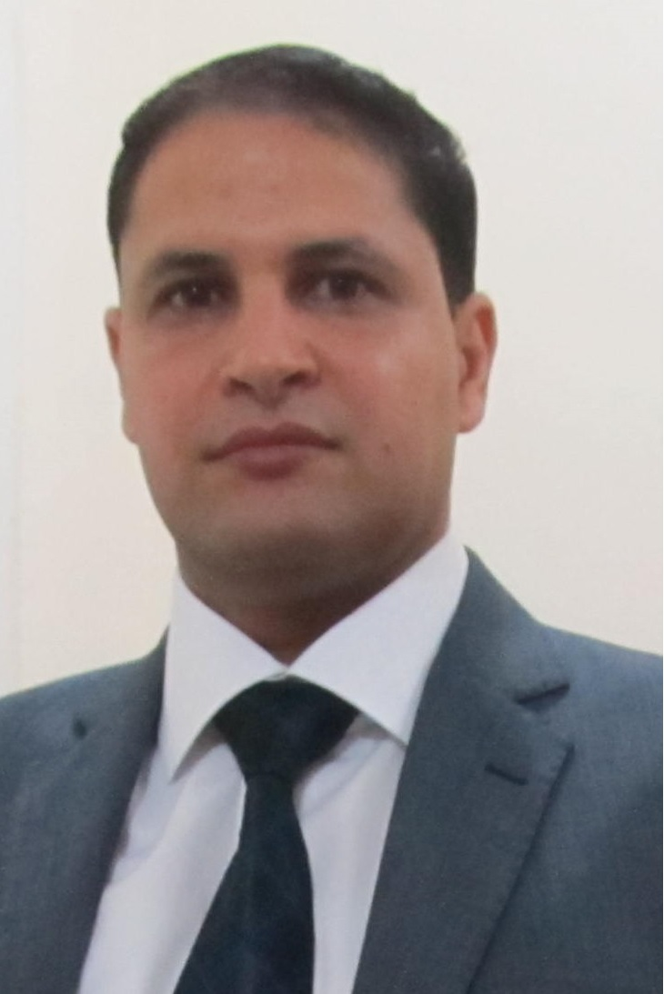

Doha - Qatar
Cell No : 01001875817
E-mail: no_yas2012@yahoo.com

YASSER OMAR MOUSTAFA SABER

Objectives
Seeking for a challenging and a suitable position for my qualifications in a reputable institution utilize my power and capacities, and enhance my skills and experience.

Personal Information
Date of Birth | : | 18th Jan 1977.
Nationality | : | Egyptian.
Marital Status | : | Married.
Military Service | : | Executed.
Have a Driving License

Work Experience
( Nov. 2009 – Until Now )  ( Nov. 2008 – Oct. 2009 )  ( Jan. 2007 – Oct. 2008 )  ( Feb. 2006 – Dec. 2006 )  ( Feb. 2004 – Jan. 2006 )  ( Feb. 2003 – Jan. 2004 )  ( Jun. 2002 –  Jan. 2003)  ( May 2000 – Jan. 2002)  ( Jun. 1998 – Apr. 2000) | Doha City – Doha – Qatar.  - The Gallery Assistant Manager.  - Responsible for all home appliances in the gallery, as it contains all the inclusions home.  - Responsible for personnel affairs.  - Responsible for customer service inside and outside the gallery.  - Responsible for the preparation of reports.  - Responsible for training new team to work in the gallery.  Doha City – Doha – Qatar.  - The Gallery Supervisor.  Ansar Gallery – City Center – Doha - Qatar.  - The Gallery Manager.  - Responsible for all things in the gallery, as it contains clothes, shoes, perfumes, baggies and another things for man and women.  - Responsible for personnel affairs.  - Responsible for customer service.  - Responsible for the preparation of reports.  Ansar Gallery – City Center – Doha - Qatar.  - The Gallery Exhibition Manager  New World Center Co. – Doha – Qatar.  - Purchasing Manager.  - Travelled to China, Thailand, Bahrain, Dubai .  - Buy accessories company such as carpets and household.  - Buy clothes, shoes perfumes and bags.  New World Center Co – Doha - Qatar.  - Supervisor.  - In clothing section, shoes section, electronic section, perfumes section, chocolates section and casher.  New World Center Co. – Doha - Qatar.  - Salesman.  - In clothing section, shoes section, electronic section, perfumes section and chocolates section.  Ghazco Co. – Alexandria – Egypt.  - Driver.  Sweet City – Alexandria – Egypt.  - Confectioner.

(Sep. 1996 – May 1998) | Institute of Tourism and Hotels,  Alexandria University, Section hostelry.  - Accumulative Grade: Very Good.
(Sep. 1993 – May 1996) | Technical Diploma.  - Department of Electricity.  - Accumulative Grade: Good.

Educational Background

Computer
  - Very good knowledge of Windows platforms.
  - Very good knowledge of Microsoft Word and Power Point.
  - Very good knowledge of Internet Browsing.
  - Very good knowledge of Searching.
Skills

Languages
- Arabic : Mother tongue.
- English : Excellent command of spoken and written English.

Personal
Hard worker, ambitious, problem solver, leadership, acceptable to other and good worker with team.

Traits

Activities
- Reading.
- Writing.
- Internet.
- Computer.
and

Hobbies

Thanks for reading and waiting your feedback

