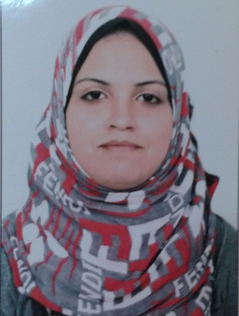

* **Personal Information :**

**First Name Middle Name Family Name**

|  |  |  |
| --- | --- | --- |
| **Reham** | **Ibrahim Mahmoud Ali Ali** | **Badr** |

**Date of Birth Place of Birth Nationality ID number**

|  |  |  |  |
| --- | --- | --- | --- |
| **15 / 11 / 1987** | **Zagazig - Sharqia** | **Egyptian** | **1300161** |

**Full Address Contacts**

|  |  |
| --- | --- |
| Sharqia Governorate – Zagazig – Elsayadeen District – Bank Eleskan Building No.5 | **Mob:(+2010)96508482**  **Home:(+2055)2345948** |

* **Educational Information :**

**Place Graduation Year Certificate**

|  |  |  |
| --- | --- | --- |
| **Faculty Of Art** | **2010** | **Bachelor of Arts – Department of Geography** |

* **Languages :**

**Language Written Spoken Reading**

|  |  |  |  |
| --- | --- | --- | --- |
| **Arabic** | **Mother Tongue** | **Mother Tongue** | **Mother Tongue** |
| **English** | **Good** | **Good** | **Good** |

* **Courses Skills :**

**Course Year obtained Place of Course**

|  |  |  |
| --- | --- | --- |
| **Cycle of The social Contract** | **2011** | **UNICEF** |
| **English** | **2012** | **Axon** |
| **Icdl** | **2010** | **UNESCO** |
| **Business Curriculum** | **2015** | **Ministry of Youth and Sports** |
| **Course of Speech and Speech** | **2019** | **College of Science for People with Disabilities and Rehabilitation** |

* **Experience :**

**Employ Years of Employment Place of Employment**

|  |  |  |
| --- | --- | --- |
| **secretary** | **2012** | **Kafrawy Motor Company** |
| **Geographic Researcher** | **2013-2014** | **General Authority for Statistics**  **(NBS) Packaging** |
| **Public Relations** | **2014-2015** | **Arab Speedball Federation** |
| **Public Relations** | **2015-2016** | **African Speedball Federation** |
| **Cashier** | **2016-2017** | **Party Pizza Restaurants** |
| **Call center and Customer Service** | **2017-2018** | **Party Pizza Company** |
| **The referee** | **2016-Now** | **Egyptian Speed Ball Federation** |

* **Special Interest :**

**\* Skill Of Communication and Supply**

**\* Ability of time management**

**\* Tranquility in the work**

**\* Proficiency deal with computer**