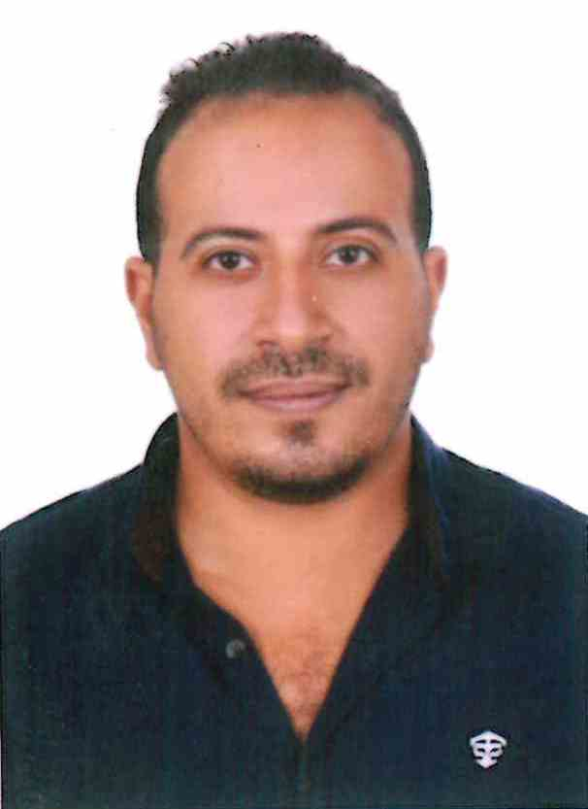Mina Ayoub Saeed Youssef

3 Boktomor St- Rod El Farag -Shubra

Mobile: 01204455785

Tel: (022) 4327894

Email: Minahero2000@gmail.com

**Personal Data:**

**• Date of birth:** January 27/1986

**• Nationality:** Egyptian

**• Marital status:** Married

**Education:**

**•** Graduated from faculty of law at 2008 Ain shams university

**•** Grade of final year : very good

**Military Status:**

* **Exempted**

**Computer skills:**

**•** Proficient knowledge of MS windows.

**•** Outstanding acquaintance with MS office applications : word , power point , excel , access.

**•** Excellent in the use of internet application.

**•** ICDL

**Language Skills:**

**•** Arabic: Excellent in written and spoken (Mother tongue).

**•** English: Excellent in written and spoken (First language).

**Professional Experience:**

I worked for Orange From 19/4/2010 till 2018 as a customer Service representative,

The Egyptian company for mobile services (Orange)

I worked for Al Ahram Beverages from 2018 till Jan 2021 as a store manager.

**JOB DESCRIPTION:**

* Agent New line activation (activating new prepaid lines through Phone).
* 110 Customer Service as a rotation for 3 months.
* Sim Swap Team as a rotation for 1 month .
* MNP team .
* Technical support at Orange Egypt
* Sale All products at drinkies Stores

**Personal Skills:**

# *•* Ambitious

**•** Fast Learning

**•** Responsibility

**•** Ability To work under pressure

**•** Ability to work in teams

**•** persuasive

**•** self motivated

**Personal Skills:**

Seeking a job a leading company to gain practical experience and enhance the technical skills acquired during academic work.

"References available request"