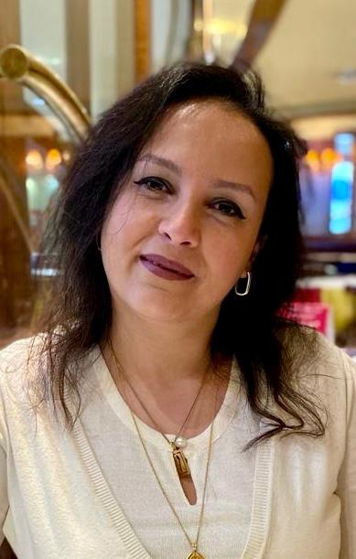
JERMEEN SAMIR MIKHEAL

Cell-phone: 01001068100
E-mail: jermeenbagdady@yahoo.com

OBJECTIVE

Looking for a challenging position in administration or HR where I can use my skills and experience for the benefit of the organization & to pursue my career objectives.

WORK EXPERIENCE

Ooredoo Telecom Kuwait
May 2017 – Mar. 2020

Title: Admin B2B

Duties:

- Coordinating between client companies & Ooreedo via emails to assist in requests, problem solving & support of Sales Staff.

Saipem S. P. A (Italian Oil Company operating in Kuwait) Jan. 2010 – Nov. 2015

Title: Senior HR Officer

Duties:

- Handling all work related to Expats visas & residencies.
- Handling all other usual HR duties same as
(Mobiles Communications, Fuel Cards, Employee ID, Office Directory, Sending & Receiving Couriers).
- Making Purchase Order.
- Filing, fixing appointments.

Montania General Trading Company - Kuwait
May 2007 – Jan. 2009

Title: Office Manager

Duties:

- Filing, fixing appointments, answering phone calls & receiving visitors.
- Typing faxes and letters in both Arabic & English.
- Handling all other usual secretarial duties

Boshehri Group “Red-Bull” - Kuwait
Feb. 2006 – April 2007

Title: Sales & Marketing Representative

Duties:

- Developing new sales contacts to increase the market share.
- Represent Red-Bull in every event to open a new market
- Maintain proper sales reports to sales manager as needed.

PERSONAL INFORMATION

Nationality: Egyptian
Date of Birth: 01 June, 1981
Marital Status: Married with 2 Children

EDUCATION

- Fager Al-Sabah School - Kuwait
General Certificate of Secondary Education - June 2000

- Alexandria University - EGYPT
B.A, Geography Department, Faculty of Arts – 2004

- The American University in Cairo – Arab Academy for Science and Technology - Diploma in Geographic Information Systems – August 2005

SUMMARY OF ATTRIBUTES

- Strong interpersonal and communication skills.
- Able to work under pressure to meet deadlines.
- Handle multiple tasks efficiently and in a timely manner.
- Self-motivated, energetic, hard worker & strong team player.

- Language Skills:
Arabic: Mother Tongue
English: Very good command (speak, read, & write)

- Computer Skills:
Excellent command of Computer skills: Office (Word/Excel/PowerPoint) Internet browsing & applications.

References Furnished Upon Request

