**Curriculum Vitae** 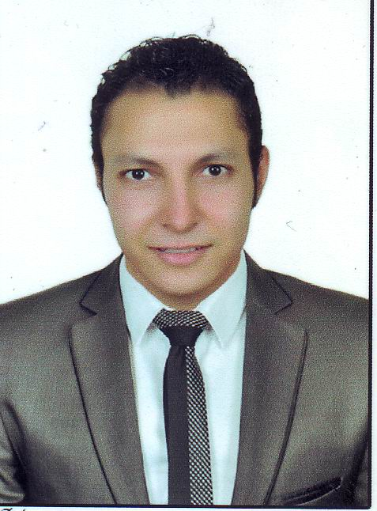

**Personal data: Position: Chef Guard Mange**

**Name :** Kamal Hana Shafeik Hana.

**Date of Birth :** 5 /8/ 1989

**Address :** Kom Ghorab , Misr El kadema_ Cairo – Egypt.

**Mobile :** 01274628136

**E-mail:** kamal.hana88@yahoo.com

**Nationality :** Egyptian

**Marital status :** Married

**Military service :** Exempt

**Qualification:**

* Bachelor of Tourism and Hotels from Pharaohs Academy for Tourism and Hotels. Hotel Management Department (2010) With Grade Good.

**Languages:**

* **Arabic** **:** Mother Tongue.
* **English:** Good.

**Computer Skills:**

* Internet – Word – Excel - PowerPoint.

**Hobbies:**

* Football – Swimming – Reading – participating in activities.

**Work Experiences:**

* Wadi Degla Club in Kitchen
* Iberotel Aqua Marina in Kitchen
* Intercontinental City Stars in Kitchen
* Waldorf Astoria Cairo Heliopolis Till now