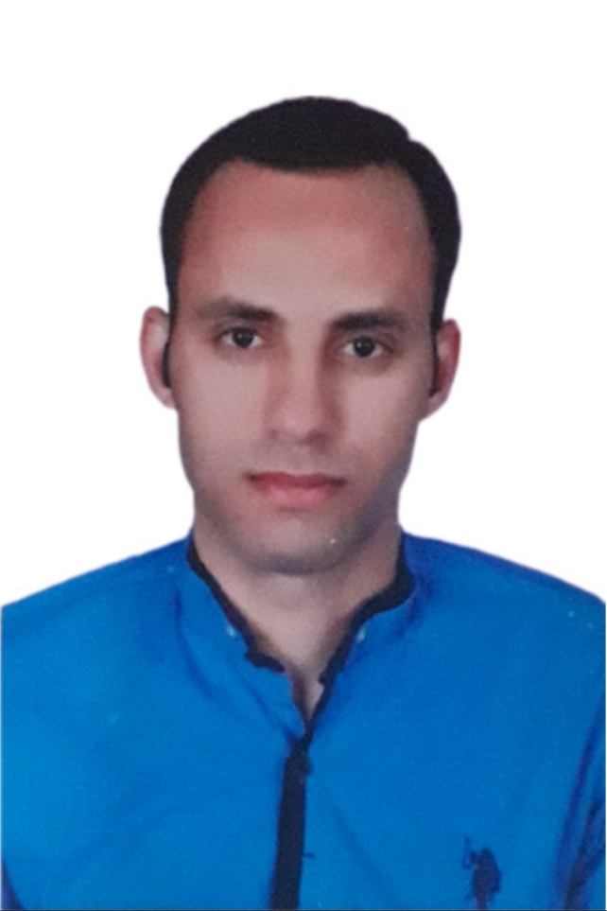

**Mahmoud Ali Sagheir**

**Petroleum & Well Intervention Engineer**

Mobile phone no: +201096460193

Email addresses: [sghm3276@gmail.com](mailto:sghm3276@gmail.com) / [mahmoud.sagher@norpetco.com](mailto:mahmoud.sagher@norpetco.com)

# Career Objective:

Seeking a challenging job opportunity as a key person in a multinational or national petroleum company in which I can utilize and develop my skills and education.

# Summary:

* Experienced well intervention and work-over engineer (+14 years) responsible for all well intervention and artificial lift operations especially Jet pumps, Sucker rod pumps and ESPs.
* Strong engineering professional with a Bachelor's Degree focused in Petroleum Engineering from Al-Azhar University with general grad of very good with the grade of honor..

# Education:

* **B.S. in Petroleum Engineering** from Al-Azhar university, May 2010.

Cumulative Grade: **Very Good** / Project Grade: **Excellent**

# Work Experience (+12 Years):

* **North Bahariya petroleum co. (Norpetco) – April 2014 till now (current).**

**Position** : Production & Petroleum Engineer.

**Location**: Well site.

* **Petroleum Institute– April 2012 to April 2013**

**Position** : Instructor.

**Location**: Menia Governorate .

# Points of Experience:

* Capable of supervising all artificial lifting starting from data gathering up to site operations for many A/L techniques (Jet pumping, sucker rod pump, ESP and Progressing cavity pump)
* Supervise all well stimulation operations (Hydraulic Fracturing and Acid treatment) designs, implantation and evaluation.
* Supervise all Wire line (E/L) (logging, RFT, MDT & perforations…etc)
* Supervise all slick line (S/L) operations.
* Design, Supervise and evaluation of all surface and down-hole well testing operations
* Post Hydraulic Fracture cleaning and well lifting
* Performing initial completion, work-over and well intervention programs
* Supervised moderate to high concentrations H2S wells.
* Ensures well control and authorizes remedial/preventive actions in case of emergency or hazards to safety.
* Supervise all TLC and electric wire line operations (all open hole logging “Resistivity, Neutron density, Gama ray, Porosity…etc”, RFT, cased hole logging, correlations, perforation permanent packers set etc.).
* Supervise all Well intervention operations such as through tubing Slick lines and CT operations.
* Working with TCP and Casing Guns perforations and correlations.
* Running all completion types (Natural Completion + Jet pumps + ESP + SRPR+ water injection).
* New well completion and recompletion operations
* Manage the logistics of the operations in an efficient manner.
* Ensure that critical operations are adequately supervised, that potential problems are identified and contingency plans in place.
* Supervises and ensures the safe execution of all operational programs.
* Have a high QHSE awareness and always consistence with company policy of HSE and procedures.

# Job Responsibilities:

* Follow up safety rules and encourage contractors to implement safety rules.
* Perform daily morning reports for all activities.
* Identify possible hazards and discuss with relevant parties.
* Work with various service vendors to ensure plans are achievable.
* Provide engineering support/advise on program implementation.
* Prepare well equipment list.
* Assist in preparation of weekly, monthly, annual, failure reports, and final well reports
* Collection, inspection, and filing of daily reports, and other well records
* Ensure well performance data such as planned vs actual time curves, planned vs. Actual well costs
* Ensure hole cleaning program.

# Training Courses:

* H2S Course.
* IWCF - Well intervention Level 3&4.
* Well performance and completion design.
* Formation damage.
* Basic Wire-line Operations.
* ESP design and troubleshooting.
* Advanced open hole logging.
* Hazard Identification and Risk assessment.
* Hazard Identification and task & Risk assessment
* Firefighting.
* Beam pumping design and troubleshooting.
* NEBOSH HSE Certificate in process safety management.
* First Aid.
* Hydraulic Fracture.
* OSHA course in chemicals.

# Skills:

|  |  |
| --- | --- |
| * Project management * Strong decision maker * Complex problem solver | * Creative design * Innovative * Service-focused |

# Personal Information:

* Nationality Egyptian
* Date of birth May 24, 1987
* Marital status Married
* Military status Exempt
* Home Address KomOmbo, Aswan, Egypt.