**CURRICULUM VITAE**

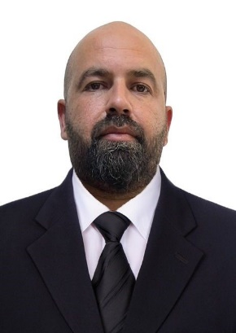

**Name**: Muslim Aqeel Hameed.

**Date of birth**: 8-Feb-1984

**Nationality**: Iraqi.

**Address**: Baghdad/ Al-Yarmouk.

**Marital status**: Married.

**Phone no.:** 07707978801

**Email:** [muslim.alani84@gmail.com](mailto:muslim.alani84@gmail.com)

**Qualifications and Certificates:**

1. **Bachelor degree in computer engineering.**
2. **Certificate in (Project Management for Engineers).**
3. **Certificate in (Leadership Tools & Techniques).**
4. **Certificate in (Risk Assessment & Controls).**
5. **Certificate in (Forming Effective Teams).**
6. **Certificate in (Quality Assurance & Control).**
7. **Certificate in (Scaffolding Inspector).**
8. **Certificate in (food safety and hygiene) from Alison.**
9. **Certificate in (safety management system evaluation).**
10. **OSHA Certificate in (occupational safety and health supervisor) .**
11. **OSHA Certificate in (personal protective equipment).**
12. **OSHA Certificate in (introduction to OSH training).**
13. **OSHA Certificate in (effective accident investigation).**
14. **OSHA Certificate in (introduction to safety management).**
15. **OSHA Certificate in (safety supervision and leadership).**
16. **IOSH certificate in (working safely).**

**Experiences:**

1. **Site engineer at International Zone in Baghdad (2011-2013).**
2. **Team leader engineer at Ericsson telecom company (2013-2015).**
3. **HSE officer at IBD co./ ENI oil and gas Basra life support camp. (2015-2018).**
4. **HSE manager at IBD co. (2018- till now )**

**LANGUAGES:**

1. **Arabic language (Read, Write & speak).**
2. **English Language (Read, Write & Speak).**

**Programs:**

1. **Microsoft excel.**
2. **Microsoft word.**
3. **Microsoft PowerPoint.**
4. **Outlook express.**
5. **Adobe photoshop.**
6. **Adobe illustrator.**
7. **AutoCAD.**
8. **Adobe reader.**
9. **Visio.**
10. **Computer programming.**