Wekome Io MyVegas Magaz i ne and MyVegas Digital. in ONE word, it's all about SUCCESS. Over 40 years al publ i shing and showcasing the best tha1 Las Vegas has Io offer in what makes Las Vegas so vibrant and exçit i ng... 1he People. Of the amazing stand outs in aur commun i ty, MyVegas i s knawn for leatur i ng the "Wha's Wha" in 1he Las Vegas warld al Successlul Businesses. Fram the Tap Dactars and Dentists for Heahhcare and Wellness, la 1he Best in aur Law and Legal field, as well as 1he movers and shakers i n Real Estate. MyVegas also lills your l ilestyle needs for Family, Pets, Res1aurants, Entertainment, Gall, Travel and so much more! MyVegas Magaz i ne can be found in over 5000 busi ness locat ions and j us! abau1 every callee !able in town. Over 1 Mi llion copies Io date! MyVegas, we're everywhere, and we're here for yau!

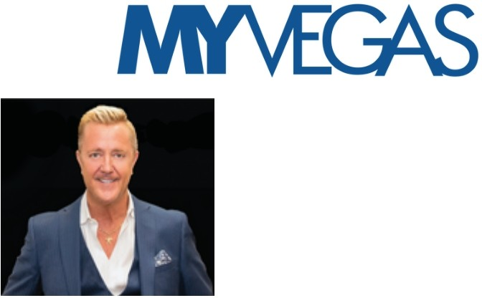

OV E R 40 Y E A R S O F LA S V E GA S HIST O R V

As locol publishers for t he lost 40+ yeors, you moy hove picked up o few of our publications in the post , including :

The Best Restaurant Guide Las Vegas Home & Garden Today's H ealth

Las Vegas Bride

Dine Out Magazine Las Vegas Women

Las Vegas H ome l mprovement Las Vegas H ealth & Fitness



TODAY, MYVEGAS BRINGS YOU THE SENTIMENT OF ALL OF OUR LOCALLY FOCUS ED PUBLICATIONS INTO ONE POWERFU L MAGAZINE .

READER INVOLVEMENT

MyVegas gels our readers involved with Online Contests, Prizes, Adventures, and Activities that stimulate reader involvement. Every quarter our New Issue Launch Party attracts up te 1500 local business owners for the larges! magazine network event in Vegas that is f ull of amazing fvn, exôtement, prizes



and entertainment. Our local business mixers ore held at our clients bvsiness locations, restovrants, and retail shops that drive real traffic te the dient's place of business, creating an in teractive experience for bath our reoders and our advertiser clients.

MYVEGAS IS YOUR MAGAZINE

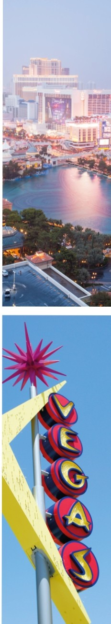

1. 500 ,000 LOCAL READERS

8

27 ,000 DIGITAL MAGAZINE VISITORS/MONTH

e 50 ,000 WEBSITE VISITS/MONTH

40 ,000 SUBCRIBERS

1. 9 ,956 FOLLOWERS

8 4 ,365 FOLLOWERS

*0* 1,693 FOLLOWERS

TOTAL: 633 ,014

THE MYVEGAS AUDIENCE REACHES OVER HALF A MILLION PEOPLE THROUGHOUT THE

LAS VEGAS VALLEY



**DEMOGRAPHICS OF OUR READERS**

* $ 150.000+ AVERAGE INCOME PER HOUSEHOLD
* 96% HOME OWNERS
* 30 - 70 YEARS OLD
* 52% FEMALE
* 48% MALE

**CIRCUL ATION AND DISTRIBUTION**

* 25,000 PRINT COPIES PER ISSUE
* OVER 1,800 DOCTORS AND DENTAL OFFICES
* 500 MYVEGAS RACK AND DROP LOCATIONS
* 500 LAWYER'S OFFICES
* 200 LOCAL REAL ESTATE OFFICES
* 200 LOCAL RESTAURANTS
* 88 COUNTRY CLUBS AND GOLF COURSES
* 65 NEW CAR DEALERSHIPS
* 20 CANNABIS DISPENSARIES
* 30 ZIP CODES FOR HOME DELIVERY
* SPEC IAL EVENTS AND LOCAL EXPOS
* DOWNTOWN SUMMERLIN MALL
* **THE** DISTRICT AT GREEN VALLEY RANCH
* TOWN SQUARE MALL
* GALLERIA MALL
* TIVOLI VILLAGE



**DELIVERED BY DIRECT MAIL AND RACKS TO UPSCALE NEIGHBORHOODS IN 30 PRIME ZIP CODES:**

* ANGEL PARK • RED ROCK COUNTRY
* ANTHEM CLUB
* ASCAYA • SPANISH HILLS
* CADENCE • SPANISH TRAILS
* CANYON GATE • SUMMERLIN
* CENTENNIAL HILLS • SOUTHSHORES
* DESERT SHORES • SUN CITY SUMMERLIN
* DOWNTOWN • SIENA

SUMMERLIN • SPRING VALLEY

* ENTERPRISE • SOUTHERN HIGHLANDS
* GRANADA HILLS • SILVERADO RANCH
* HENDERSON • SEVEN HILLS
* INSPIRADA • TUSCANY
* LAKE LAS VEGAS • THE LAKES
* LONE MOUNTAIN • THE MESA
* MOUNTAIN'S EDGE • THE RIDGES
* MCDONALD RANCH • TOURNAMENT HILLS
* NEVADA TRAILS • TPC SUMMERLIN
* PECCOLE RANCH • WHITNEY RANCH
* QUEENSRIDGE

... AND GROW ING EVERYDAY

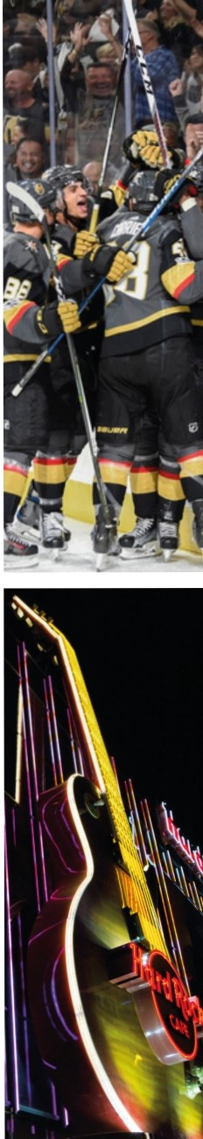

**SPE CIAL SE CT IONS**

## MY BEAUTY AN D FIT N ESS

* + MY HEALTHCARE
  + MY BUSI NESS AN D CAREER
  + MY CHARITI ES
  + MY DATI NG LIFE
  + MY ENTERTAI NME NT
  + MY SPORTS
  + MY HOME AN D GARDE N
  + MY REAL ESTATE
  + MY KIDS AN D FAMI LY
  + MY LEGAL
  + MY MON EY AND I NVESTME NTS
  + MY PETS
  + MY RESTAURANTS
  + MY SEN IOR LI FE
  + MY TRAVEL
  + MY GOLF





### DIGIT AL MARKETING MAKEOV E R

**$500 GIFT FOR Y OU!**

I S Y OU R DI GIT A L P LA N NOT WOR K I NG H O W Y O U I MA G I N E D ? GE T Y O U R F R E E DIGIT A L MA R K E TI NG MA K E OV E R W ITH MY V E GA S !

W E E X AM I N E A L L OF Y OU R DI GIT A L MAR K E TING

F R O M TOP TO B O TTOM. DU R I NG OU R F IRST ME E T U P , W E W IL L SH OW Y OU N E W A N D E X C I TING TIP S TH A T

W IL L PU L L I T A L L TOGE T H E R , H E L PING Y O U R DIGIT A L MA R K E TI NG B R I NG Y O U TH E BUSINE SS

T H A T Y OU'V E A LW A Y S W A NTE D I

**WE COVER EVERYTHING, INCLUDING:**

* **SOCIAL MEDIA MANAGEMENT OF ALL PLATFORMS**
* **ONLINE AD MANAGEMENT - FACEBOOK AD MANAGER AND GOOGLE CPM AND CPC**
* **EMAIL MARKETING AND CRM'S**
* **FUNNEL MARKETING**
* **CALENDAR MARKETING**
* **CALL TO ACTION MARKETING**
* **COMPLETE WEBSITE AND APP OVERVIEW**
* **ONLINE BUSINESS GENERATORS**
* **CONSISTENCY IN YOUR DIGITAL PLANS**

**POP UPS, CREDENTIALS... AND MUCH MORE!**

FREE CONSULATION AND REVIEW - REG $ 500!

BOOK YOUR APPOINTMENT TODAY EMAIL: [DIGITAL@MYVEGASMAG.COM](mailto:DIGITAL@MYVEGASMAG.COM)





**DIRECT MAIL ZIP CODE COVERAGE**

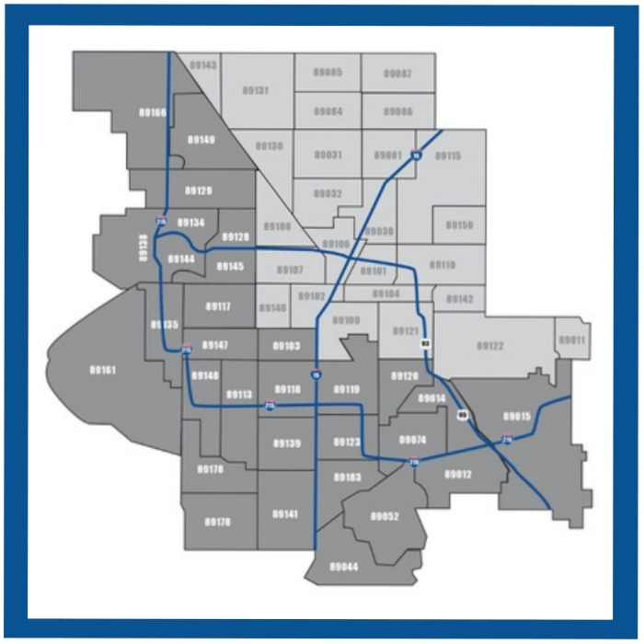

•

30 MYVEGAS

ZIPCODES



**TOP DOCTORS TOP REAL ESTATE PROFESSIONALS**

SPACE DE ADLINE o NOV 20 ON STREEL FEB / MAR

**TOP ATTORNEYS BEST OF MYVEGAS**

SPACE DE ADLI NE o FEB 20 ON STR EEL MAY / JUNE

**TOP WOMEN OF SUCCESS**

SPACE DE ADLINE o MAY 20 ON STREET, AUG / SEP

**TOP MEN OF SUCCESS**

SPACE D E ADLI NE o AUG 20 ON STR E E L NOV / DEC

ISS UE

**123**

I S S UE

**223**

ISS UE

**323**

I S S UE

**423**

