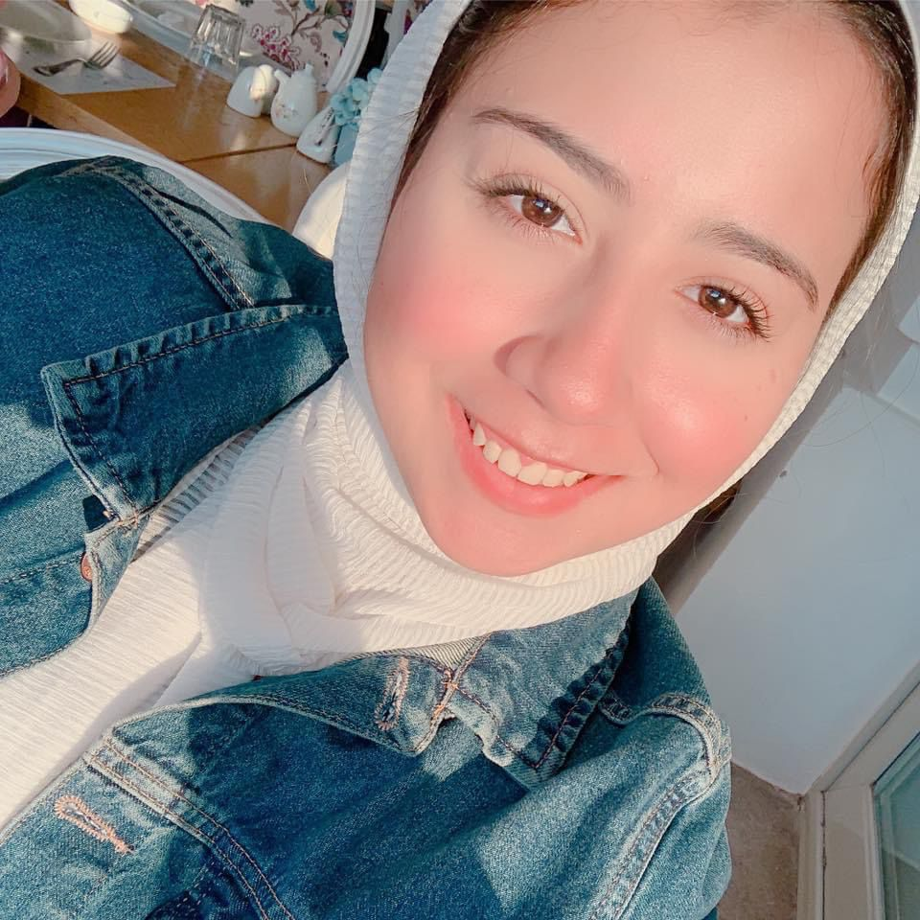 |  | nourhan ibrahim  Social Media Moderator
Profile  I am a fresh graduate, Passionate about Learning and get knowledge & Experiencing New Challenges. I  am a Multi-Tasking & Capable of motivating Others to reach our Goals. sociable, intensive team  motivator and has a good communication skill to build a good Relationship with team work.  Contact  PHONE:  01200466364  EMAIL:  noraebrhim@icloud.com |  | EDUCATION  Media& Mass Communication  October 6 university  2017 – 2020  Public Relation & Advertising Department  WORK EXPERIENCE  Social Media Moderation at TIA Store  2020-2023  Internship AT Egypt Air PR department  2019–2020  Sales at ElTaiser Company  2018–2019  SKILLS  Ability to work under pressure,  Customer service, Time Management, communication skills, Negotiation, Digital Marketing, Microsoft word, Microsoft excel & Microsoft Power Point

Languages

Arabic (Mother Tongue), English (V.good)

