Curriculum Vitae

Mohammed Mustafa Mohammed Saleh.  Current Address 2 Othman bin Affan st - Baghos - Fayoum Governorate and City.  Mob. -002 01018400236  Email: v.ib40@yahoo.com | 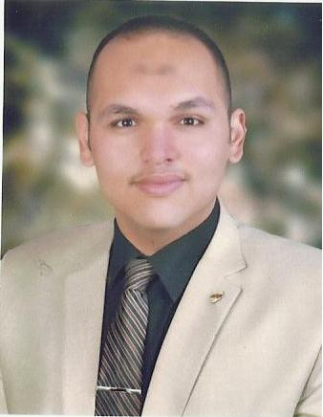
Name : Mohammed Mustafa Mohamed Saleh.
Age : 30 years.
Date of birth : 24/4/1991.
Nationality : Egyptian.
Marital status: Married.
Position on conscription: final exemption.
Academic qualification / Bachelor degree from the Faculty of Law, Beni Suef University with a good grade / May 2012 .
Other scientific degrees / Master of Law in the general criminal law and specialized from the Faculty of Law Cairo University in 2013, and 2014 with a very good grade of 81%; and a PhD researcher in the Department of Public Law "specialization of criminal sciences and international law."
empolyement qualifications:-
1- Freelance lawyer from 2012 to 2015.
- • I practiced as a free lawyer during the period from the date of my graduation in 2012 until September 2013 in my father’s office, may God have mercy on him, Mustafa Muhammad Saleh, the lawyer in cassation. And who was taught by law from his earliest years.
- • I practiced as a free lawyer in the office of Prof. Dr. "Hussam Lotfi", Professor of Law, Faculty of Law, Beni Suef University, during the period from 11/2/2013 to July 2014.
- I practiced the free legal profession in my private office from July 2014 to 05/24/2015.
2- I was appointed as a lawyer and legal advisor to Fayoum University in the management of university cases starting May 24, 2015.
3- I previously worked as a legal advisor and researcher for the Egyptian Customs Authority from 2019 to 2020.
4- I am currently working at the Ministry of Justice as a “legal researcher” as of 01/06/2020 until now.
Skills: -
1- I have the skill in preparing defense notes and lawsuit newspapers and pleading before all courts of different degrees.
2- I have the skill in drafting and editing contracts, whether at the level of individuals or companies and bodies.
3- Proficiency in dealing with computers and using the office group and the Internet, especially since I am a PhD researcher and all the jobs that I worked in previously and currently are complete with my dealings with computers and the Internet
Languages ​​/ Arabic Mother tongue and English language.
Yours sincerely, Regards,,.
Introduction to you
Mohammed Mustafa Mohammed Saleh

