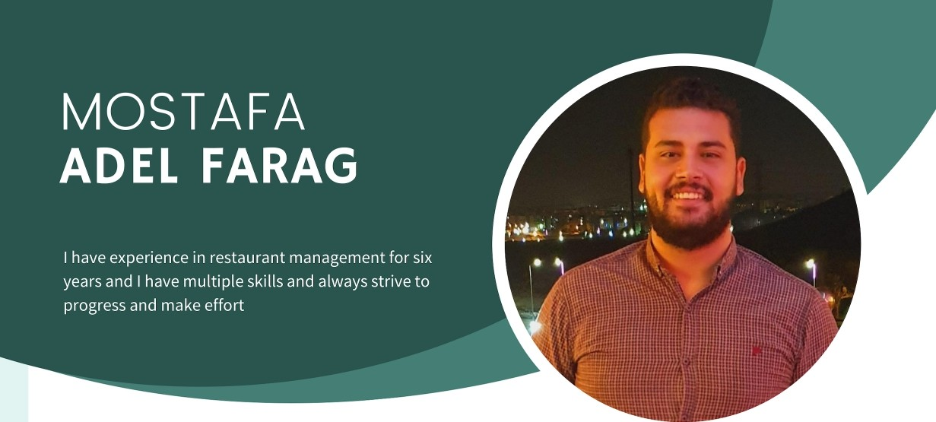
EXPE RI E N C E
PakPak Restaurant General Manager 2021 Until Now

PakPak Restaurant supervisor 2020 to 2021

Assistant Manager at PakPak Restaurant 2019 to 2020
Agent Call Center 2018 to 2019 at exceed
Chief assistant 2016 to 2017 at Crepeno Restaurant
Sales representative - 2015

Law firm training - 2014 NEW LAW STUDENT
- Attending court sessions for various cases
- Preparing case papers and working on them

CONTACT
+20 112 805 9990

Mostafafarag955@gmail.com

15 May City - Helwan \ Cairo
B I RT H DAY
17/12/1995

E D U CAT I ON
2020
Cairo University
Bachelor of Laws

S OC IAL S ITUAT I ON
married

N I LITARY C E RT I FICAT E
Exemption

S KI LLS
Good communication
98%
Team wo rk
J00%
work under pressure
95%

LAN G UAG E S
A ra bic - N eg ative

E ng lis h - good

