Curriculum Vitae
Name: Mohamed Abd-Elghany Shaddad 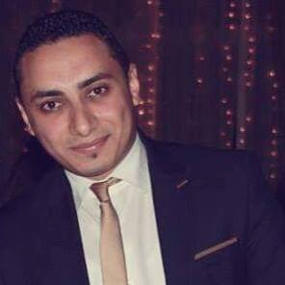
Mobile: 01007461071
Home: 5070819
Email: Mohamed_shaddad@alexu.edu.eg
Mohamedabdelghany84@yahoo.com

Personal Data
Date of birth : 10/11/1986
Address : 47 dr. Mahmoud slim, Miami , Alexandria, Egypt.
Military service : Fully Exempted
Nationality : Egyptian
Gender : Male
Marital status : married
Career objective
Seeking a challenging position in the field of teaching public relations and advertising and press, this provides an opportunity for both responsibilities and future advancement.
Education
- Qualification : Bachelor degree of Mass communication , Cairo University.
- Department : Public relations and advertising.
- Overall grade : Good
- Graduation year : June 2008
- Pre-master studies from faculty of Arts Media Division Alexandria University. (press)

Languages
Arabic : Mother language
English : very Good
Computer skills
- ICDL (internet - Excel - Access - Word - Power point - IT).
- Deal with most of applications software.
- Internet skills (Browsing – E-mail)
Courses
- ICDL (internet - Excel - Access - Word - Power point - IT).
- English course at Military institute. (2010)
- Arabic Language Course from faculty of Arts to be registered in Master Studies.
- HR course. Oct 2010
- Photoshop cs6

Work Experience
- Media specialist at Alexandria University.
- Press and media specialist at Marseillia group real estate.
- Public relation and advertising in supreme council of universities (Information and communication technology project ICTP.
- Press and media specialist at Mena real estate.
- Worked as a reporter in AlMasry Alyoum – Alexandria office.
- Training in the Egyptian telecom company at the public relation department.
- Worked as a reporter in Eletihad Alsakandary Web site.
- Had the first position In the competition of graduation projects at the faculty.
- Article writer in Alyoum-7 news paper.
- Develop Strategic Plan for the University of Alexandria for the period from (2012:2017).
- Organize seminars and conferences of the Supreme Council of Universities.

Personal Skills
- Ability to work under pressure with the team.
- The ability to integrate quickly with the team.
- Able to work independently
- Have experience in a leadership role.
- Friendly and outspoken person.
- Presentable.
- Organized.

Medical History

- No recorded of any serious diseases or illness.

Hobbies

- Reading, writing, surfing the net, swimming, sport practicing, listening to old music and traveling.

