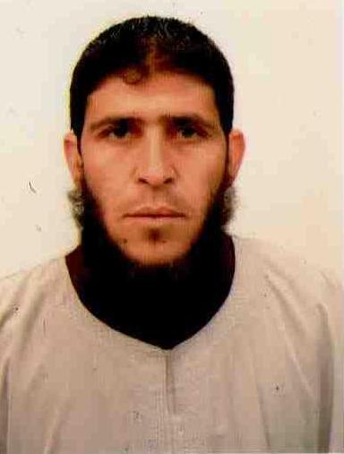  
  
  
  Samir Akkouchi  
VSA, Isser, Boumerdes, Algeria   
 mob: (+213) 561 473 065  
E-mail address: samir_35dz@yahoo.fr  
Born: 23/05/1980  
Nationality: Algerian  
Marital status: Married  
Driving license: Category (B) 2005  
  
  
***DEUA in Mechanical Engineering***

(Degree in applied university)  
degree university applied option Maintenance of rolling machines  
  
09/1999 - 07/2003 |> DEUA Maintenance Option in Mechanical Engineering.  
University of Boumerdes  
  
09/1998 - 07/1999 |> Bachelor of Science series.  
High School K'rim Belkacem Isser

Missions and occupation:  
* - Prepare a preventive maintenance plan.  
* - Determine the needs of each workshop.  
* - Manage staff and park equipment.

Occupation:

02/2005 - to date, Professor of Electrical Automobiles, mechanical, duct and construction equipment maintenance.  
Vocational training center  
  
**In computing**:  
• Office: Fluent

**Other**:   
• Reliability and punctuality.  
• Respect and ease of communication  
• Ease of adaptation, learning and assimilation  
• Organizational skills and responsibilities  
• Teamwork  
• highly motivated  
  
language skills  
• French> Current.  
• Arabic> Current.  
• English> Good.

Leisure and Extracurricular activities  
• Sport.  
• Internet.

**Other**  
• National Service emerged.