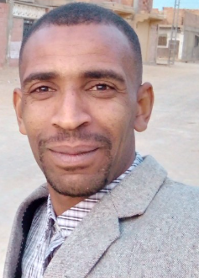
CURRICULUM VITAE

>First Name : TRIA
> Name : FAYCAL
>Date of birth : 09/07/1983
>Place of birth : Sidi Amrane W Almughayir

> Nationality : Algérienne
> Familial status : Maria
> Mobile : 002136.67.84.38.38
> Email : trfaycal@hotmail.com
> Study Levels : 9eme A F

> Diploma : mechanical
PROFESSIONAL EXPERIENCE
> As. Drilling Mechanic At BAAT assigns BOHAY 31.01.2006 to 19.02.2007
> Mechanic at Private STATION BEKOUCHE. .01.07.2004 to 01.10.2005
> As. Drilling Mechanic At Flache Service assigns DALMA .19.10.2007 to 30.08.2009
> As. Mécanicien Drilling At Flache Service assigns DALMA .17.08.2010 to 19.12.2011
> As. Drilling Mechanic At Flache Service assigns DALMA .31.08.2012 to 26.07.2015
> As. Drilling Mechanic At Flache Service assigns DALMA. 01.05.2016 au 10.05.2018
>As. Drilling Mechanic at Ilas Service assigns kCA Deutag Rig 211. 10 Months
> As. Mécanicien neveu N1 assigns Nesr Company 14/07/2022 To This Day
LANGUAGES
> Arabe : Alright
> Anglais : Cood
> Français : AVERAGE
OTHERS
> light driving license
> Team spirit
> Good physical condition
> Available immediately
> Sense of responsibility
> Able to work day and night

