# _CamScanner.jpg

**Ehab Ehab**

**Mohsen Store Manager**

# DETAILS

|  |  |
| --- | --- |
| **Contacts**  **Sheikh Zayed , 6 October city**  **Emil :** [**ehabmohsen31@gmail.com**](mailto:ehabmohsen31@gmail.com)  **Mobile / WhatsApp : +201007599198**  **Driving License : Yes** | **Nationality : Egyptian**  **Date Of Birth : 19/2/1985**  **Marital status Single**  **Military status: Not required** |

**Professional Summary**

**A commercially aware, driven, well organized and hands on Manager who is very good**

**at sharing her expertise in the most helpful ways with her colleagues. Maxine achieves**

**great results in her store because of the way she leads, develops and inspires her team.**

**She has a bold, brilliant and clear style of leadership that is at the core of how she runs**

**things. Right now she is looking to grow, develop and progress within a retail business**

**and is looking for a unique place to work on that will provide her with**

**many new opportunities for development and careern.**

**Employment History**

|  |  |  |
| --- | --- | --- |
| **Job Title : Store Manager**  **ALDO SHOES LEVENT SHOES MENBUR,EG**    **Men’s Club** | | **Employer :**   * **Retail Group Egypt ( R . G . E )** * **LEVENT CO** * **Fashion International Group ( F. I .G )** * **Men’s Club Fashion** |
| **Start & End date** | | **City: Cairo**  **All Malls of EGYPT** |
| **Jan 2012**  **Jul : 2015**  **Mar: 2021**  **Jan: 2022** | **Jun 2015**  **Aug 2020**  **Nov 2021**  **Till Now** |

**WORK EXPERIENCE**

1. **Worked in a unit of one of the largest retail companies in Egypt, Retail Group Egypt.**

**Which has more than one international brand throughout the republic,**

**I specifically worked for the A L D O brand**

**I worked as a salesman until I got a job as a store manager ,**

1. **Worked in one of the Turkish branded store**

**Levent SHOES**

**It has a single branch in Egypt**

**Where we started establishing the branch from A to Z.**

1. **Work at spinsh brand shoes MENBUR as a Store manager .**

**I made the decision to switch from the footwear family to fashion. It is much bigger and I had the biggest challenge to gather the largest information to communicate successes. Then they joined one of the largest men’s fashion companies in Egypt Men’s Club as a branch manager, which has 103 branches across the country.**

**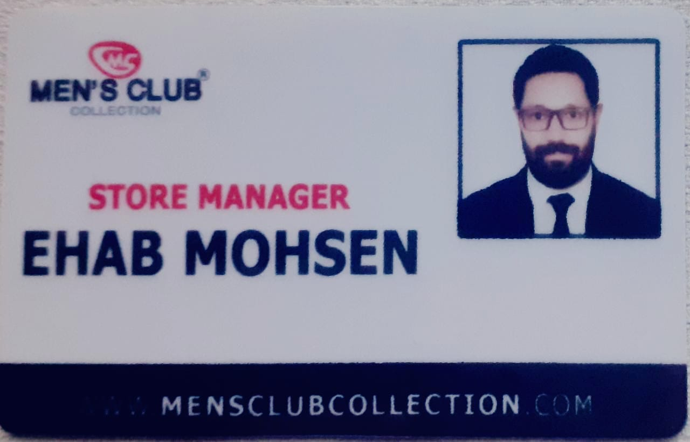**

**It is some of the tasks and responsibilities.**

**Appropriately scheduling staff based on business trends to ensure adequate staffing**

**at all times.**

**Putting the customer at the heart of everything the retail store team does.**

**Creating a buzz around new product launches.**

**Delivering first class customer service and operational excellence.**

**Giving expert advice to customers and advising them on product choice.**

**Ordering more stock once existing levels reach a certain point.**

**Achieving results through the retail sales team.**

**Maintaining proper inventory controls.**

**Achieving phenomenal sales through the highest standards of customer care etc ..**

**AREAS OF EXPERTISE**

1. **Driving sales**
2. **Customer service**
3. **Increased sales**
4. **Operating standards**
5. **Staff performance**
6. **Visual merchandising**
7. **Improving processes**

**Education**

|  |  |  |
| --- | --- | --- |
| **Institute for Advanced Academy** | | **Degree** |
| **Start & End date** | | **Management Information System** |
| **Nov:2004** | **Nov:2008** |

**Skills**

**Communication , Good time management , Leadership and Teamwork , Hard Working , Flexibility and Adaptability , Self-motivation ,Creativity , Problem Solving , Leadership Skills .**

**Computer Skills**

**Microsoft Office , Word , Excel , Outlook , Power Point , Photoshop , Internet**

**CRM database administration and client management software.**

**Courses and Certificates**

**ICDL , stay gold , P & L**

**Languages**

**Arabic , English**

**Hobbies**

**Sports ( Swimming )**

**

