**Personal Data**

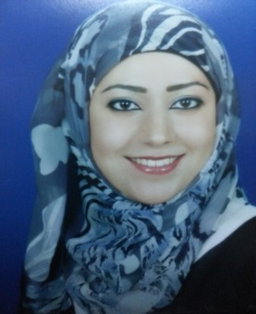**Name:** Rawan Bassam   
**Date of Birth:** 1992

**Nationality:** Jordan

**Born:** Kuwait

**Phone:** +965-50444826/5

**E-mail:** [Monistr86@gmail.com](mailto:Monistr86@gmail.com)

**ــــــــــــــــــــــــــــــــــــــــــــــــــــــــــــــــــــــــــــــــــــــــــــــــــــــــــــــــــــــــــــــــــــــــــــــــــــــــــــــــــــــــــــــــــــــــــــــــــــــــ**

**Career Objective**

Searching for a job that I could enhance particularly my course in your company.

**Education:-**

* 2009 – 2013 Bachelor of Management Information Systems (MIS)

Al Balqaa' Applied University / Amman (Jabal-Al Hussein)

G.P.A: 3/4

* 2008 – 2009 Tawjihi / scientific

Al-Kuwait Al-Ahliyya School / Kuwait (Al-Farwaniya)

G.P.A: 91, 0%

**EXPERIENCE:-**

**Secretary,**

Dr. AHDI AL-BADER (Plastic surgery clinic) Sharq

Feb, 2014 to 27 Jun, 2018

Dealing with patient inquiries and arranging appointment, filing, communicating with hospitals and other health care professionals and booking appointments for operations.

Performing out all clerical support duties including: photocopying, typing, filing, telephone answer etc.

**Skills:-**

* Accuracy in the performance of work.
* The possibility of communicating with customers
* Work under pressure.
* Data Entry.
* MS Word, MS Excel

**Training Courses:-**

OCT 2012 till DEC 2012 (Written objections & written authorization and Delivery checks) Income & Sales Tax Department / Amman (Jabal-Al Hussein)

**Language:-**

|  |  |  |  |
| --- | --- | --- | --- |
| **language** | **Reading** | **Writing** | **Speaking** |
| **Arabica** | Native | Native | Native |
| **English** | Very good | Good | Good |

**Thank you for your close attention & for giving me some of your time to read my C.V, I'm looking forward to join your company.**