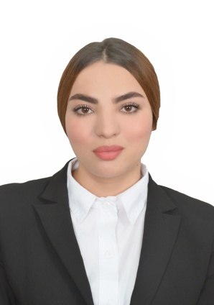**Surname and First Name**: Souha Bouazzi.

**Date of birth** :12/10/2001 .

**Height :**165 cm

**Weight :** 60 kg

**Address**: City of Souany Laaneb 2 El Kef,Tunisia.

**Phone Number** : +216 (53551630).

**Nationality** : Tunisian .

**E-mail**: [bz.souha123@gmail.com](mailto:bz.souha123@gmail.com)

**Obtained a baccalaurate degree in Economy and Marketing.Looking for a job as a hostess in your company .**

**EDUCATION AND TRAINING**

**2021:** Baccalaurate (" **Economy and Marketing**"),High School Al Afek ,Kasserine.

**PROFESSIONAL CARRER AND INTERNSHIPS**

**November 2021-February 2022 :** Internship in “**BNA**” Bank , Kasserine.

-Fufill tasks set by supervisors from several departments.

-Process desposits ,payment and handling transactions.

**July 2021- November 2021 :**Worked as a seller in a clothes shop “**MALEK SHOP**”, Kasserine.

-Welcome the customers,help the customers to find suitable ítems in the store .

-Ring up purchases and check for stock .

**PERSONAL SKILLS**

Behaviour: Teamwork , patient , responsable , friendly , assertive and has rigor at work.

Language skills: **Arabe :** mother tongue

**French:**fluent **Anglais**:fluent

Digital skills: Microsoft office: Word, Excel, PowerPoint.