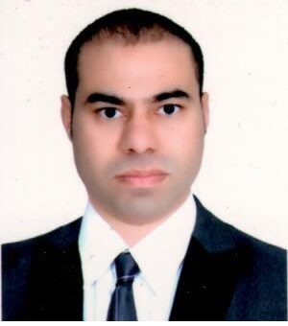**E-Mail:abdelgawad@ymail.com**

**Phone :+201018410183 (Egypt )**

**UAE.EXP: 10 Years.**

**Profile**

Trained retail professional looking for a suitable opportunity as SM/ASM or Others.

**Educational Qualification**

**DEGREE**

High School – GED.

commercial diploma graduated.

**Training & Seminar Attended**

* Diploma Course in Adobe Photoshop & AutoCAD
* Landmark Group at UAE
* Customer Really Matters (2017).
* Oracle system- POS & SIM.
* Certificate of fire fighting.

**Personal Qualifications**

* Excellent Interpersonal skills.
* Fast Leaner and Willing to Undergo Training.
* Proficient in Written and Oral Communication of Arabic Languages and Fluent in English.
* Customer Service Oriented and resolve any problems.
* Call center experience.
* Knowledge with Photoshop & AutoCAD.
* Computer Literate ( MS World , Excel, Power Point & Internet).
* Driver License At UAE.
* Retail License 2018.

**Work Experience: UAE**

**Presently working as assistant manager**

**MAX Land Mark Group (Retail) From MAY 2007 to April 2019.**

**•** Coach and support other team members.

• Process sales when necessary. (PSA).

• Maintained sales records for inventory control.

• Maintain product levels appropriately.

• Greeted customers and determined their needs.

• Ensure that the store is clean, safe and presentable for customer.

• Hire and train new employees for the sales floor or other departments (e.g. Shipping and receiving) Generate and review daily sales report.(KPI).

• Conduct regular audits of the store’s physical, practical condition to ensure quality.

• Interact with the public via social media and maintain the store’s online presence.

• I got 7 times employe of the month + 20 times icon awards.

**-Sales Out door fast drive Rent car from May to July-2019.**

Luxury Car Rental Service. Executive transfer services to and from International Airport in UAE. Executive for Businessman and Businesswoman who want to travel in Luxury and tray a certain of level elegance and class. Private sightseeing tours of the wonderful slights and views to be found around UAE VIP chauffeur services available 24 hours a day.

**Working Experience in Egypt.**

- Midstar company for 7 months.

-Memphis Airlines Co .from2003 till 19 May 2007

- Essam Computer Center.

-Egypt Tailoring Co. **ETC.** From Aug-2019

-Swiss Gaments company **SGC. Quality check Department.**

**Personal Data**

Nationality : Egyptian

DOB : Feb 17, 1982

Languages : English & Arabic (Mother tongue)

Marital Status : Married

Military Status : Expected

Passport No. : A16961442

I hereby certify that all information given is true and correct to the best of my knowledge. I fully understand that any falsehood or misinterpretation of any fact herein shall be enough for rejection of my application of employment.

Thanks and Regards

Abdel