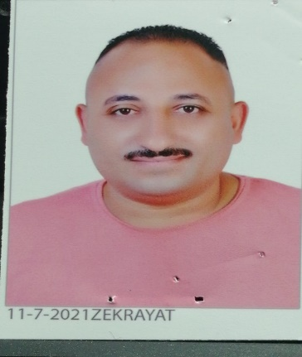

Walid Magdy

**EQUIPMENT TECHNICIAN**

**Bachelor of industrial education – mechanics division – production technology specialization.**

**EDUCATION**

**|GMC {from 20/5/2006 to 15/6/2007}**

**| Agility Logistics {from 30/6/2009 to 31/3/2022}**



Arabic

Ads

Engish

**LANGUAGES**

Work under pressure

**SKILLS**

01002310549

01559973900

Waledmagdy275@gmail.com

**PROFESSIONAL EXPERIENCE**

Microsoft Office

**21/ 2/ 1984**

**MARRIED**

imbaba - Giza

Military Services

exemption

Strong decision maker

Complex problem solver

* solver

Creative design

**| Goldy for maintenance {from 15/11/2007 to 11/5/2009}**

Innovative

Microsoft Word

Microsoft PowerPoint

Microsoft Excel

ATA ENTRY

**Hydraulic course.**

**Computer**  **Skills**

**Certifications**