**Emad Danial Soliman** 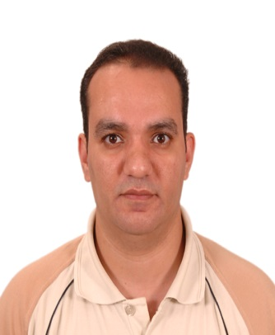

Telephone #: 01225823074 / 0224579034

Address: 36 El Belkini street Rod El Farag , Shubra, Cairo, Egypt

E-mail addresses: [solimanemad@yahoo.com](mailto:solimanemad@yahoo.com)

Over 19 years of experience in the Quality field of pharmaceuticals. I started as analyst in quality laboratories of El Alamia Company for Ethyl alcohol, acetic acid manufacturing and enhanced my experience with 16 years of work in quality control department of Mina pharm pharmaceuticals.

**Detailed Experience:**

**Quality Control Senior section head, mina pharm co. May. 2003 – March 2019:**

* Review analytical method validation reports to ensure their compliance to regulatory requirements.
* Create raw material specifications and test methods with reference to pharmacopoeia.
* Perform SOPs, work instructions and test guidance for laboratory.
* Monitoring temperature and humidity in different locations using data loggers and communicate Q.A in case of deviations.
* Review and approve analysis results of stability and intermediate products.
* Ensure that preparation of all test and volumetric solutions is done correctly and following GLP.
* Analyze raw materials to ensure that they meet specifications before their use in production.
* Operating and calibrating different chemical laboratory instruments. For instance: HPLC, UV, FTIR, Dissolution, Spectrofluorophotometer, Melting point device, Refractive index, Particulate matter counter, capillary and rotatory viscometers, Optical rotation device, ovens and muffles , Analytical and top balances, Conductivity meter, pH meter, Titroprocessor and Ion selective electrodes. Also physical testing instruments like: Disintegration, friability, Sieve analyzer, Hardness tester, flowability and leakage tester.
* Test quality of drug products during production process to ensure that they meet standards of potency, purity, uniformity, stability and safety.
* Water analysis.
* Participating in validation activities like cleaning validation and analytical method validations.
* Working with GMP, GLP requirements.
* Preparing annual needs of chemicals, Glass ware.
* and follow up Purchasing requests and storing it in appropriate places.

**Quality control analyst, EVA co. May 2002 – May 2003.**

* Prepare reagents and supplies for chemistry labs.

* Analysis of raw material.

* Analysis of intermediate.

**From Nov.1999 to May 2002chemist in EL alamia comp.for supp. pharma. industries.**

* Quality control lab analysis of raw material, Analysis of finished products supervise the production.
* Bio – chemical process for production of natural alcohol from fermentation of yeast.
* Bio – chemical process for production of natural vinegar from acetobacter bacteria.

**Education:**

* Bachelor of science from Helwan University, 1999;
* Certificate from (maslahte El chemia) Ramses St.in Food analysis.
* Master degree in quality management. Arab academy for science and technology.

**Training:**

**All necessary facilities for GMP.at Mina pharm co. by qualified trainer.**

**Language skills:**

Fluent in Arabic and English.

**Computer skills:**

* Professional in Microsoft office (Word, Excel, power point)
* Oracle.
* International Computer Driving License Certificate.

**Personal skills:**

* Very accurate in analysis
* Interested in operating and maintaining laboratory equipment
* Willing to learn new things and develop old methods
* In problem solving, I always trying to find the easiest and the simplest solution
* Thinking outside the box.

**Activity:**

Reading.