**HOSSAM AHMED SHAIKHON**

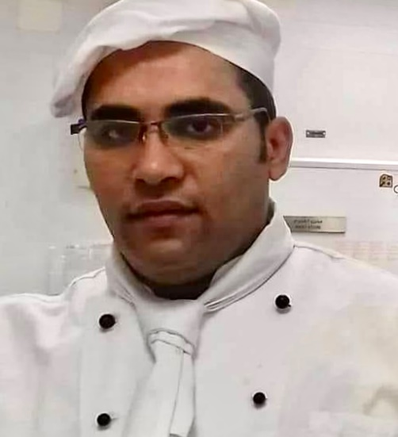

**Mob phone**: 00974 66 22 98 56

**Home phone**: 00201061819565

**Email:** shaikhon335@gmail.com

**Nationality**: Egyptian

**Religion:** Muslim

**Gender**: Male

**Date of Birth:** 18.07.1983

**Education**

# Plus, two pass, Diploma of Tourist and Hotel Services

**Mother language: Arabic.**

**Second language: English nice speaking and writing and reading.**

# Job Objective

To work as a chef CDP with your organization where I can employ my excellent culinary services.

**Kitchen experience and skills:**

**>** Kitchen hygiene and organization,

> Butcher skills for use the correct tools for correct items,

> Main kitchen section with different category of food,

> Traditional Arabic food,

> Teamwork with all team and manage,

> VIP food and big event:

(I work with Amwaj team for Lusail cup in Qatar And FIFA World In Qatar 2022 AND Asian cup 2023)

**Training:**

* **Personal hygiene**
* **Kitchen hygiene**
* **Great food safe food**
* **Food coast**
* **First in First out**

**Highlights of Qualifications:**

I am starting my career as butcher helper after head butcher,

After interring the main kitchen as a cook, I take training from our professional chef,

* Profound knowledge of transitional techniques of food training
* Familiarity with all laws related to health and sanitation
* Wide knowledge of F&B training techniques
* Skilled at scrutinizing costing of food and labor management
* Ability to perform in high work stressed environment
* Ability to organize meetings, give briefings of menu
* Ability to maintain effective communication between Director, F&B and line staff
* Ability to conduct meetings and menu briefings

**Professional Experience:**

**Company :** Amwaj Catering Services. Doha Qatar

**Position :** Arabic CDP

**Period :** DECEMBER 2011 -Till Present

|  |  |  |  |
| --- | --- | --- | --- |
| **Company** | **:** | LACOSIN CATERING HOTEL (DOHA, QATAR) | |
| **Position** | **:** | ARABIC COOK | |
| **Period** | **:** | May 2010 - December 2011 | |
| **Company**  **Position** | **:**  **:** | Pyramisa Hotel (EYGPT)  Chef de partie | |
| **Period** | : | May 2007-March 2010 | |
|  |  | |  |
|  |  | |  |
|  |  | | |

**Declaration**

I hereby declare that all information are true and correct to the best of my knowledge and belief

Place: DOHA