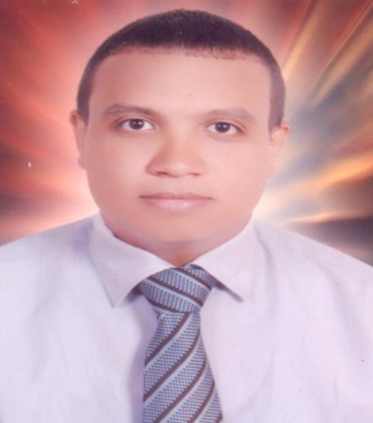

H E S H A M   A H M E D  E L S A W B Y

P E R S O N A L  I N F O R M A T I O N

.      Marital Status:     Single.

.      Nationality: Egyptian .

.      Date Of  Birth :  June 2nd 1982.

.      Place  Of  birth :  Cairo; Egypt.

.      Address: 58 Omar Bin Elkhattab St, New Maadi , Cairo Egypt.

.     phone numbers: (+202) 27256525.

.     mobile: (+20106)8993957

 .    e-mail:hesham_ahmed2081@yahoo.com

OBJECTIVES

. seeking challenging position   in  the fields  of  customer

  Service or sales whereby my personal and educational

Skills can applied.

Employment

**From Novmber 2015 till  Present day :**

**Warehouse Manager** at Plastic Industry Technical Corporation

Responsible for everything related to his administration and for the safety of the warehouse system in cooperation with the administrative manager and is responsible for all documents that he approves and decisions he takes with full responsibility. He must issue loading orders and work orders, participate in senior management meetings and express opinions on results and decisions. Responsible and supervising each of:

-Warehouse coordinators

-Store keepers

-Warehouse workers

**From April 2008  till  October   2015:**

Store Keeper at Plastic Industry Technical Corporation

Responsibilities

- Executing exchange, return and addition permits

- Responsible for organizing storage units, shelves and stock safety according to storage instructions

**From march 2006 till march 2008:**

Sales   executive    at    ( urgent   for   office    supply )    Cairo, Egypt.

Responsibilities:-

. to sell and promote  all company  products as copiers, printers, inks , pens and pencils .

To   handle the outdoor   and indoor  meetings  with  the potential clients

      To  apply monthly sales report for G.M.

**From January 2005  till  march  2006:**

public   relation  officer   at (go  Egypt  travel ) Cairo.

Responsibilities

to  handle  all governmental procedures   related  to  the  company such as driving licenses,  airport permission, branches and staff registration.

To handle visas issuing to the company guests.

EDUCATION

Bachelor degree in social service studies, high institute

Of social studies, Nasser city June 2006

**Courses**

**ICDL 2010 ( word –Excel –power point –Access –internet –windows ) .**

LANGUAGES

Arabic: mother languages

English: fair written, speaking and understanding

Activities  and  interests

Community service helping disabled children and assisting kinder garden teaching

Recipient of open water diving course at hurghada.

Organizer in African nations cup 2006.

References furnished upon request