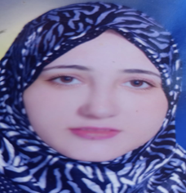

**kholoud mohammed kamal**

[kholoudmk9@gmail.com](mailto:kholoudmk9@gmail.com)

EL SHIKH ZAYED – EL GIZA

Mobile: 0106097814

**About me:**

Date of Birth: May 6, 1990

Place of birth: Cairo, Egypt

Marital Status: Married

Nationality: Egyptian

**Languages:**

Arabic

English

**Skills**

Computer

Leader tea

Friendly

**EXPERIENCE**

Training in EI Bank El Ahly "Data Entry"

Teaching in Higher Institute for Computer and Business Administration.

**Education**

Bachelor of Management Information Systems - business management

Overall rating very good (84.48%) - Mansoura University

Pre-Master of Business Administration, Faculty of Commerce - Mansoura University.

**COURSES**

International computer driving license (ICDL)

Microsoft office specialist

**Activities**

Reading

Sports

Travel

**Profile**

I am trying to get a challenging, competitive and suitable position that will fully utilize my combined skills, and qualifications in relation to your needs, while providing me with new and absorbing challenges.

**Key Qualifications:**

Planning, organizing, coordinating, controlling and delegating skills.

Good in conflict management and stress management.

Ability to make decisions

Teamwork and helping others get things done

Working within a team

Team leadership