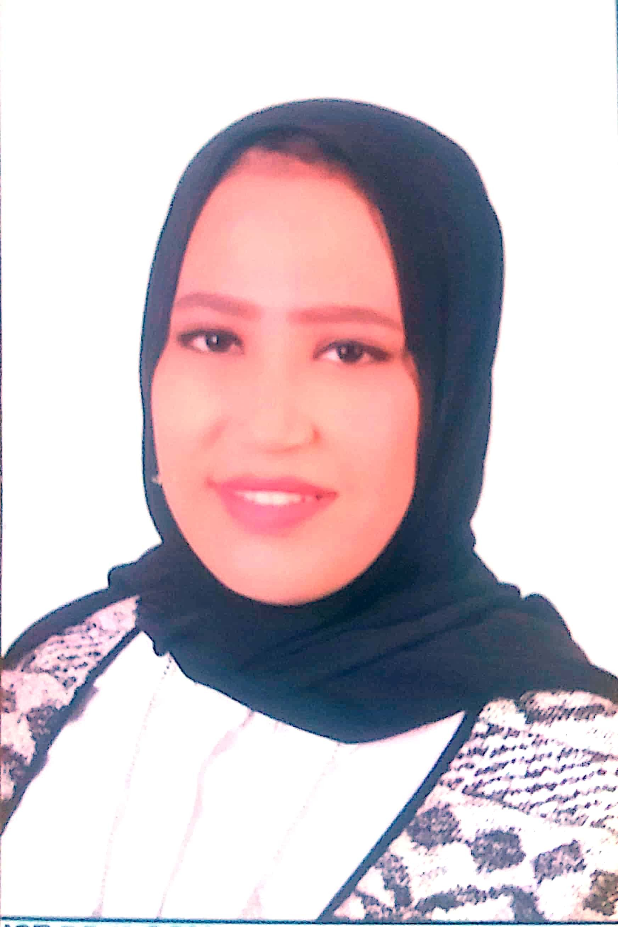Rehab ashraf Abdullah mohamed [arehab657@gmail.com](mailto:arehab657@gmail.com)

Al-Mansheya Street, talbiyah, Faisal, Giza Mobile : 01093891743 / 01118261963

Gender : Female

Marital Status : single DOB : 6/4/1994

City : Giza

State : Al-Mansheya Street, talbiyah Faisal, Giza Country : Egypt

# CAREER OBJECTIVE

To work for an organization which provides me the opportunity to improve my skills and knowledge to growth along with the organization objective.

# ACADEMIC DETAILS

* English [2016] with aggregate of 75% from High institute for tourism and hotels for 6 October
* Arrival and departure terminal [2017] with aggregate of 95% from Egyptair / cairo Airport
* Microsoft Office [2018] with aggregate of 90% from Royal soft House

# WORK EXPERIENCE

|  |  |
| --- | --- |
| • | Worked as Reservations officer in Adventure tours from Jan 2022 to Apr 2023 |
|  | Role :System reservations customer service |
|  | |
| • | Worked as Reception and customer service in Cairo dan tours from Oct 2022 to Dec 2022 |
|  | Role :Receiving customers, answering all your questions and inquiries, and meeting their needs |
|  | |
| • | Worked as manager assistant in El Alsson International School, New Giza from Jul 2018 to Aug 2021 |
|  | Role :Installing and operating computers and solving simple problems |
|  | |
| • | Worked as Secretarial in Iral tours from Apr 2017 to May 2018 |
|  | Role :Sending and writing answers to hotel reservations via e-mail, organizing appointments and responding to customers |
|  | |
| • | Worked as Sales in Msir life insurance from Jun 2017 to Oct 2017 |
|  | Role :sales outdoors |
|  | |

**FIELD OF INTERESTS**

* Interest in technology and everything new
* Explore and learn about artificial intelligence
* Its entry is the work data on the system

# SKILLS

* Self-Motivated, Multi-Tasking and Fast Learner
* Achieving objectives and meet tight deadlines
* Presentation and Communication Skills
* Capable of working independently and collaboratively as a team member
* Ability to cope with pressure and tolerance of change

# INDUSTRIAL EXPOSURE

## Industrial Visit at:

* Data Entry

## Inplant Training at:

* Adventure tours

# ACHIEVEMENTS

* I participated in a small role in an artistic work at the university
* I mastered the job of a reservations officer in less than 4 months
* I learned photography

# STRENGTH

* Smart
* Fast absorption
* reconnaissance
* System work
* Date entry