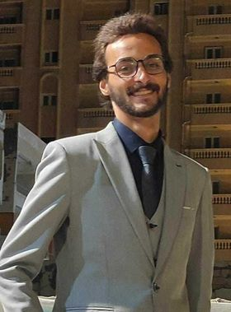Mostafa Salah Nabeh
Egypt, , Alexandria
•01271628236
Moustafa.salahm97@gmail.com
Age: 26  Single
Summary
A well presented, articulate and confident individual with a proven ability to provide exceptional
customer service and ensure that passengers leave with a lasting positive impression of their flight.
Having a outgoing personality, good interpersonal skills and the ability to work in a multi-national team
environment with confidence and minimal supervision. Comfortable working in a fast paced environment
and able to build and maintains good relationships with work colleagues and passengers through a
genuine desire to understand their needs and support them.
Education
Graduated from Egoth hotel tourism, department of airline management .
Languages

Arabic – Native language.

English – Speak fluently and read/write with high proficiency

French language is good.
Skills
Customer Service Skills.
ability to serve customers as per protocols and
excellent attendance record
• Communication & Interpersonal Skills
. Ability to communicate with people from a
variety of cultures
• Grooming & Charachter
Adherence to high standard of grooming.
Ambitious, organised, helpful, patient and
Honest.
• Flexibility.
Ability to work for long periods and under
pressure.
• Team Work.
Work confidently within a group. Mentoring
inclination and ability

Air hosbitality course
Hobbies
- Travelling
- Reading
- Swimming
- Running

