Curriculum Vitae

Personal Data
Name | Ahmed Mohammed Saber Ali Elgabry.
Gender | Male.
Date of Birth  Place of Birth | 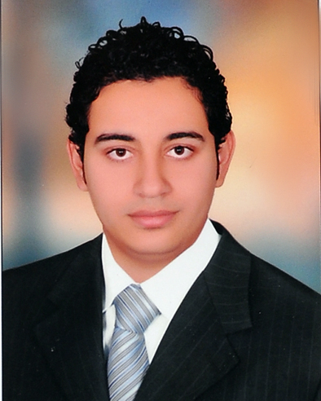  26/5/1991.  Sahraget el kobra met ghamer - dakahlia
Nationality | Egyptian.
Marital Status | Married
Military Status | Exempted.
Tel. | 050-4820682 .
Mobile No. | 01274942132.
Email | a.elgabry91@YAHOO.COM.
Address | Sahraget el kobra met ghamer - dakahlia  Zhraa_nasrcity_cairo
Driving License | Valid.

Education
University Degree | Bachelor of accounting, Faculty of commerce English section program.
University | Zagazig University.
Grade | Good(74.4%).Total (789/1060)
Graduation Year | May 2012.

skills
Computer courses | Excellent (ICDL)
Accounting courses  Course of human resources (HR) | - Course on using accounting at EXCEL  program.  - Course at computer serving the (inventories, sales, purchasing)and preparing budget using Excel  - Course at patch tree , Quick Book , Elhades program  - Diploma Of The Secrets Of Success

Work Experience
- | Senior accountant at INTERMEDICAVET imv. co(from03-2018-12/2018)  An Accountant , Sales& Marketing Representative At Futurevet, Veterinary  Pharmaceutical Company (from 01-2013-2018 //2019until now)  An Account at ECARU company from (1-7-2010 to (1-10-2010)
- | Training at Banque du cairo from (1-8-2011) to (31-8-2011) at customer service department. Making update for customer data, opening account to them and issuing bank cards.

Special skills:
- Ability to work alone and in group and motivated to my work.
- Ability to learn new technologies and work under pressure.
- Good in communication with people.
- Good listener, confidence, hard worker.
- Adapting to changes & flexibility.
- Quality focus.

Any missing data will be available upon request
Wishing my qualifications would meet your requirements.

Thanks & Regards

Refrences: | References will be furnished upon request
IT WILL BE GREAT HONOR FOR ME TO BE APART OF YOUR TEAM
THANK YOU FOR YOUR TIME

