***c.v***

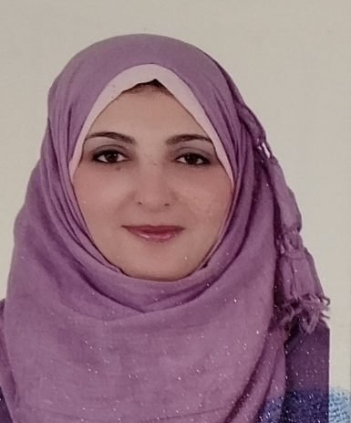

***Address: Al-Shorouk***

***Mobile / 01150876410***

***Qualification: Bachelor of Social Service***

***Languages/English very good***

***Excellent computer with all programs***

***Experience: 15 years of marketing and public relations experience***

***Good experience in dealing with clients, contract work and managemen***