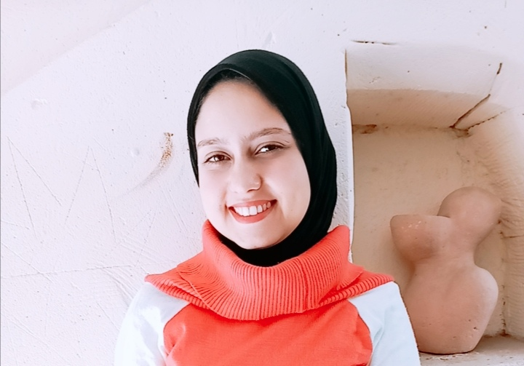
Aya Samir Abd Alhamid Hendawy EL Shandidy
Mahmoud Sami Al-Baroudi St،branching from Gamal Abdel Nasser St، Itay Al- Baroud،Beheira، Egypt

Tel: - 01096501498
- 01281020756

E - mail : ayaelshandidy8819@gmail.com
PERSONAL INFORMATION:
Date of Birth: 1/9/1998
Gender: Female
Marital Status: Single
Nationality: Egyptian
EDUCATION:
- Graduated from the Faculty of Specific Education, Alexandria University, with a general grade of excellence ( 2016-2020)
- I got the second place in the university class
- Section : Technology and Software
- Department: Programming and Electronics
COURSES:
- I got a course in Python language from New Horizon in Alexandria
- I got an accredited degree in ICDL from the Electronic Design Office of the Naval Academy in Alexandria
- I trained in Photoshop course
- I got an accredited certificate in a course on human development and public relations
- I took a software design course from the Armed Forces Systems Institute
SKILLS:
Language | - Fluent in Arabic  - Very good in English
Computer knowledge | (Windows, MsOffice , Visual Basic for Applications, Adobe Photoshop, Python programming language, Autocato )

OTHER INFORMATION:
- Member of the Students' Union of the Faculty of Specific Education, Alexandria University (2019/2020)
- One of the organizers of the Rowad Conference (20/30) (2018/2019)
One of the organizers of the Youth Forum Conference at the Scientific Research Palace in Alexandria ( 2018/2019)
REFERENCES:
Available upon request

