**Doha Mahmoud**

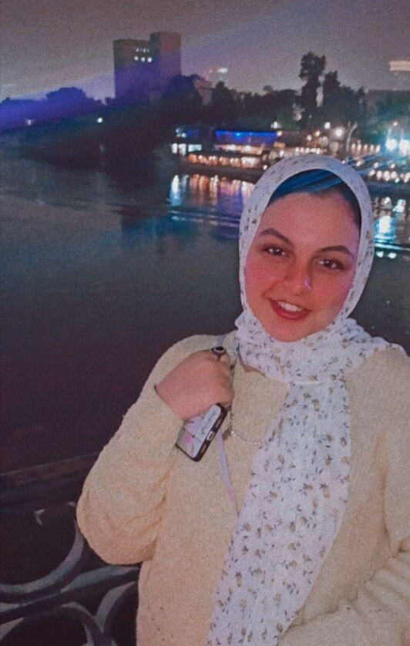

**Personal Information**

**Date of birth:**30/3/1999

**Nationality:** Egyptian

**Address:**29 Tawfic Elhakim St -Shoura Elkeima

**Phone :** 01143378511

**Email:** doha.mahmoud51@gmail.com

**Languages:**

English : good

**Skills :**

. working with team effectively

.able to work well under pressure

.good in creating public relations

. have a good communication Skills

.good at dealing with customers

**Education :**

I have a bachelor's degree in PR and Marketing from Cairo university

**Experience :**

**(Courses)**

- marketing council : July 2018 ( student activity -link )

-Tv preparation : March : April 2018 (Nile media )

- Journalism training : June 2018 ( Al- Raya News website )

- English : 24 October 2020 :April 2021 (English capsules )

**Jobs) )**

tele- sales : March : May 2020(PL kids company )