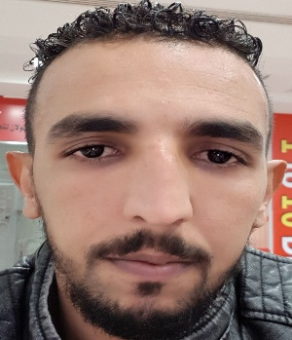

**Noreddine JANAH**

**Address:**

**City- Country: Sidi Jabber, Beni Mellal MOROCCO**

**Phone Number: +971507765773**

[**Date and place of birth**](http://context.reverso.net/traduction/anglais-francais/Date+and+place+of+birth)**: 25/06/1990 in Sidi Jabber BENI MELLAL**

[**Family status**](http://context.reverso.net/traduction/anglais-francais/Family+status)**: Single**

[**Nationality**](http://context.reverso.net/traduction/anglais-francais/Nationality)**: MOROCCAN**

**E-mail: noreddinejanah1990d@gimail.com**



***ACADEMIC QUALIFICATIONS***

**2015 - 2016  : Diploma of Technician in Mechanical Manufacturing**

**2013 - 2014  : Diploma of Qualification in General Mechanics**

** 02/05/2016 - 31/05/2016 : Internship at the factory of sugar and refinery (SUTA) MOROCCO**

[***PROFESSIONAL***](http://context.reverso.net/traduction/anglais-francais/professional+experience) ***EXPERIENCES***

work on the Turing machine and make the gears

German auto mechanic

: Driver of the agricultural machinery and transport of food products



[***COMPETENCIES***](http://context.reverso.net/traduction/anglais-francais/information+technology+skills) ***DOMAINS***

**Computing skills:**

**-** Office tools: (Word- Excel- PowerPoint)

**Language:**

**-** Arabic: Mother Tongue

- French: Advanced

- English: Intermediate****

***HOBBIES AND INTERESTS***

**- Sports**   **:** basketball,swimming, fitness.

**- Voyages**  **:** traveling and discovering new places.

**- Other :** Reading and writing, teamwork.