Awatef Khaled Eid Alwaseef
Tel:01008507747,
01066962089

Email: awatefalwaseef@gmail.com
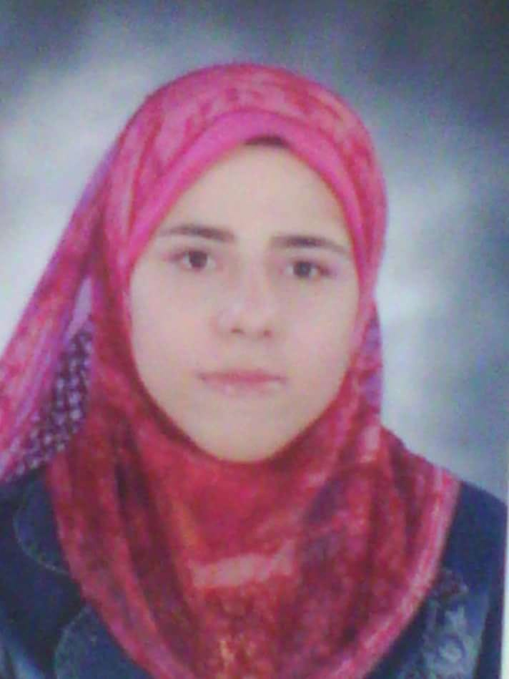

Career Objective:

A Creative self-motivated translator. Desire a career opportunity, which will offer a challenging avenue to build up my skill sets and professional experience with potential career advancement.

Skills

- Good interpersonal communication skills.
- Able to manage multiple and competing priorities under tight deadlines.
- Analytical.
- Synergetic (Team work oriented), proactive, and think Win-Win oriented.
- Aware of Window operating systems, and some popular software used in office work: Word, English and Arabic typing, and Internet.

Experience, Education & Training

I am working now as a political writer in the European centre for the studies
I am working as a radio announcer at radio90 fm

2021 Specialised translation (Politics – Media – Economics)
Centre for foreign languages and professional translation
Cairo University

Worked as a foreign journalist in the following newspapers:

2019 -2021 El-Tareeq

2017-2018 El-Muwatin

2015 -2016 El-Nabaa

2010-2014 Al-Dostor – Al Qahera

2010- 2011 General English courses
Advanced level - 402
The school of continuing education
The American University in Cairo
Grade: Very good

2009 Editor and director of a documentary
My Graduation project

2009 Bachelor of Science in Media Arts (Section of Radio and Television)
The High Institute of Mass Communication Arts
Grade: Excellent

2008 Contributing as an editor and a director in training TV programs made by students
News – Social programs – Children programs

2007 Achievement certificate in Translation of Mass Communication
The High Institute of Mass Communication Arts
Time of the course: 60 Hours

Languages:

Arabic: Mother Tongue
English: Good – reading, writing, and speaking

