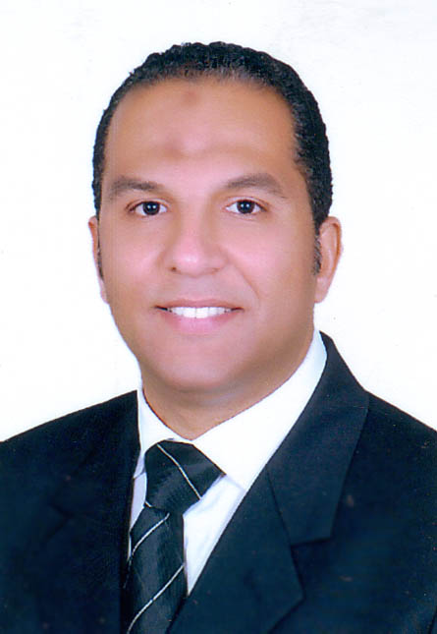
Ashraf Rashed
Villa95Al Yasmine Compound–1st Settlement
Mobile: 0100-6212899 – 015-55533384
E-Mail: ashraf2002ar@gmail.com

GERMAN TEACHER:REQUIRED JOB

Objectives:
Seeking a challenging full time job in a competitive environment where my technical, interpersonal skills and educational background can be applied and developed

Education:
- Bachelor of mass communication Cairo University.

Work Experiences

- Dates from: 1st February 2014 till now.
- Organization: Retail German teacher.
- Experience: Traum Schule (Tauberbeschofsheim – Germany).

- Dates from: 06th June 2011 till 31th December 2013.
- Organization: Hotel manager
- Experience: Paradise - Hurghada.

- Dates from: 11th April 2010 till 31th May 2011.
- Organization: Hotel manager.
- Experience: Princes golden five – Hurghada.

- Dates from: 12th October 2008 till 10th April 2010.
- Organization: Assistant hotel manager.
- Experience: Golden five Almas - Hurghada.

• Dates from: 06th May 2006 till 30th August 2008.
- Organization: Front office manager.
- Experience: Hotel Sheraton – arabella (Frankfurt – Germany).

• Dates from: 06th May 2005 till 30th March 2006.
- Organization: Rooms division.
- Experience: Iberotel Makadi beach - hurghada.

- Dates from: 3rd January 2004 Till 05th May 2005.
- Organization: Front Office Manager.
Experience: Iberotel Makadi Oasis - Hurghada.

- Dates from: 15th February 2003 till 1st January 2004.
- Organization: Assistant Front Office Manager.
- Experience: Iberotel Makadi Oasis.

- Dates from: 09th August 2001 till 28th January 2003.
- Organization: Front desk supervisor.
- Experience: Beach Albatros resort - Hurghada.

- Dates from: 21th July 2000 till 19th July 2001.
- Organization: Shift leader.
• Experience: Arabia beach - Hurghada.

- Dates from: 03rd June 1998 till 12th July 2000.
- Organization: Front desk Clerk.
• Experience: Westin resort - Hurghada.

Language Skills

Arabic: Mother Tongue in spoken & written.

English: Fluent in spoken & written.
German: Fluent in spoken & written.

Personal Data:
  - Date of Birth : October 08th,1974
  - Marital Status: Married.
  - Nationality: Egyptian.
*Military status: Exempted.

Interpersonal Skills:

Able to learn, Adaptable, Ambition Drive, Confident, Cooperative, Creative Listener, Organized, Self-motivated, Effective listening and reading, good negotiation skills.

Training Courses:

=============

1- Front office skills (Tourist ministry).

2- F & B skills (Tourist ministry).

3- Train the trainer skills (Tourist ministry).
4- ICDL Course (Cairo university).

**مستشار تحكيم تجاري دولي ومقيد بقوائم غرفة التحكيم بلجنة حقوق الإنسان برقم قيد 10356
Partner of the international arbitration organization

**محكم دولي معتمد وعضو الهيئة الدوليه للتحكيم ولجان فض المنازعات بين شركات القطاع الخاص ومقيد بقوائم المحكمين الدوليين برقم قيد 18495

**Deutsch Kurs von Goethe B1.

