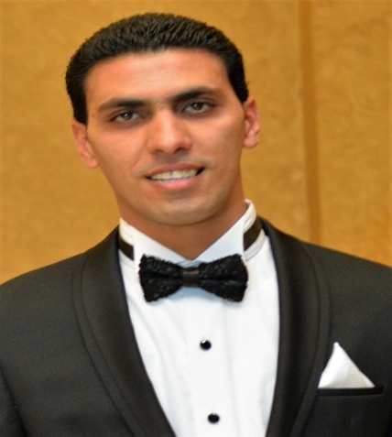Ahmed Adel Abo Elfotouh

|  |
| --- |
| **Career Objective:** |

I am highly interested in developing my knowledge, skills, expertise, and career in a manner that utilizes my enthusiasm and leads to professional recognition thus allowing me to enhance and develop my professional skills to help the company advance by achieving its short & long term goals & objectives in a very responsible and honest way.

|  |
| --- |
| **Profile:** |

* Very high potential to quickly absorb and retain new information and procedures.
* Highly self-motivated and capable of motivating others.
* Patient, proactive, goal-oriented, and serious in handling responsibilities.
* Skilled at building strong team environments and developing open communications.
* Enjoy group thinking and work effectively alone or as a co-operative member in a team.
* Capable of handling multiple tasks, projects, and responsibilities simultaneously.

|  |
| --- |
| **Personal Information:** |

* **Address:** 4 Al Maamounst – Moharambek - Alexandria - Egypt
* **Mobile:**01010110129
* **E-mail:** ahmed.elghobarey@yahoo.com
* **Nationality:** Egyptian
* **Date of Birth:** 17-october 1988
* **Martial statues:** Married
* **Schoo:**El abasya school

|  |
| --- |
| **Academic Qualifications:** |

**University:** Faculty of Commerce - Alexandria University.

**Major:** Accounting.

**Graduation Year:**2012.

|  |
| --- |
| **Work Experience:** |

**Company :** National Institute Of Oceanography & Fisheries (NIOF).

**Position:** head of payroll section .

**Experience:** September 2007 till present.

|  |
| --- |
| **Language:** |

**Arabic:** Mother Tongue

**English:** Very good (Speaking, Writing, Reading)

|  |
| --- |
| **Computer Skills:** |

* Very Good at using Microsoft Office.
* Very Good at using Internet.

**Hobbies:**

* Football.
* Travelling to different places.
* Reading.
* Writing.
* Swimming .
* charity work.