# Curriculum vitae

**Name : Taher Farag Abd Elwahed Ali**

**Address : Abo Elmatamier- Elbeheira**

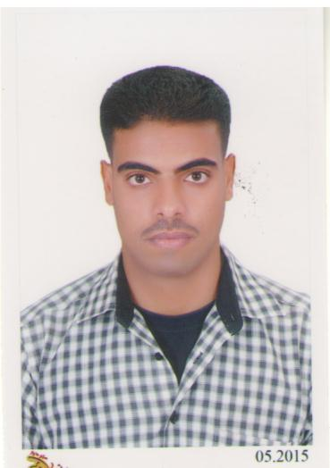**Date of birth : 3_1_1990**

**Marital status : Married**

**Nationally : Egyptian**

**Military service : completed**

**Contact phone : (002)01111459663**

**email** : taherfarag1990@gmail.com

**Special skills:**

* Advanced analytical abilities & creative problem solving.
* The ability to design and implement plans to meet the set target.
* Aggressive drive to succeed in meeting challenges.
* Good negotiations, communications, and leadership skills.
* The ability to train, leads, motivate & develop a large size staff, maintaining highest efficiency levels.
* Experience in turn around & reorganization operation to enhance productive, revenues & profitability.

**Personal skills:**

* Excellent interpersonal communication skills.
* Enthusiastic hard working and listing skills
* Able to work efficiently within a group or individually.
* Ability of work under pressure.
* Sales & customer service oriented.
* Very good communication skills
* High capability to convince.
* Very good interpersonal skills.

**Computer Skills:**

* Introduction of Computer System.
* Computer Skills (Word & Office & internet ) -
* Good Typing Skills. -

**Education:**

* Bachelor of tourism and hotels Alexandria University .
* **Educational dibloma(degree)Damanhour University**
* **Amadeus E-ticketing&Emds diploma**

**With the following tasks:-**

**Task1:- handling all types of passengers reservations**

**Task2:- E-ticket(s) inssuance**

**Task3:- E-ticktet void**

**Task4:- E-ticket(s) refund**

**Task5:- E-ticket(s) revalidation**

**Task6:- E-ticket(s) reissue /exchange**

**Task7:- EMD issuance for extra services**

**EXPERIENCE :-**

**Employe in El Etihad el araby for tourism and light tours from 2014 to 2016**

**Language:**

|  |  |  |  |
| --- | --- | --- | --- |
| **Name** | **Read** | **write** | **Talking & understanding** |
| **Arabic** | **native** | **native** | **native** |
| **English** | **Very good** | **Very good** | **Very good** |
| **Russian** | **good** | **good** | **good** |