**Name:** Mohamed Omar Harera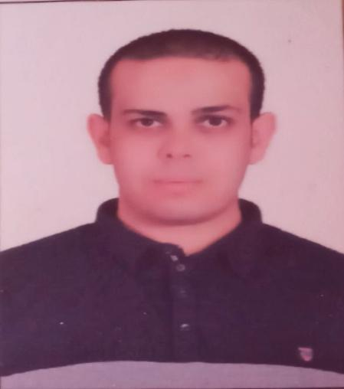

**Military service:** Exemption

**Nationality:** Egyptian

**Mobile :** 01009025525

**Email :**mohamedharera.it@**Hotmail.COM**

Email : mohamedharera.it@gmail.COM

**Career objective**

Build a strong and a highly qualified career in Network solution and administrating, through working in productive and creative team **to** apply experience and knowledge gained through practical work and training, Network solution

.

**Technical Skills:**

* **Operating Systems:**

1. **CISCO configuration:**

* CCNA&CCNP switching and submitting roles , creating vlans
* Diagnose, troubleshoot, infrastructure problem.
* Plan, coordinate, and implement network security, voice and wireless solutions.
* Monitor network performance to determine whether adjustments need to be made , and to determine where changes will need to be made in the future.
* Confer with network users about how to solve existing system problems.
* Configuring Cisco - Switches, Routers, firewall, Wireless and IP Telephony.
* Configuring IPTV LAN ,WAN and Designing it AND Maintenance it(routers, switches, pcs).
* CCNA routing roles and protcols
* CCNA security and voip and monitoring network
* knowledge at tomcat and configure it
* Cisco switching creating vlan and configuring it.

**2- MS SERVER configuration:**

1-MS-Windows server 2019 administration, maintenance, new installation, service packs

**3- Server +**

install, configure, and maintain various types of hardware and software, which often involves creating user accounts, carrying out backup and recovery functions, and monitoring the performance of servers at all times,configure, manage, and implement Hyper-V machines

**4**-**Experience Windows Sever 2008, 2012.2016** installation, Managing backup and recovery, Antivirus software, Trouble shooting LAN, printer trouble shooting. Making of LAN cables. TCP IP, Active Directory knowledge. Knowledge or Cisco IP telephony , Hyper-V

**5-VMware VSphere 7.0**

ESXI deploying defining multiple virtual servers on a single host machine. Virtualizing Windows servers and connecting them to networks .

6-- **micros opera, MICROS-FIDELIO Materials Control** installation , administration and managing

7- Solution - Attendance, installation , administration and managing

8- **SUN** - installation , administration and managing

9- **spicework Close Tickets**

**10- Sophos XG**

**11-TrueNAS &QNAP**

**12**-**HikCentral** **Professional**

**13- LG Procentric Monitoring**

**14- Solarwinds Monitoring**

**15- bitdefender gravityzone control center**

**16-Manageengine audit plus**

**Languages:**

∙ Mother Tongue – Arabic Language.

∙ English – Good

| **language** | **read** | **write** | **understanding** | **Conversation** |
| --- | --- | --- | --- | --- |
| **Good** | **Good** | **Good** | **Good** | **Good** |

**Soft Skills**

* Team Player
* Leadership capabilities
* Interactive and fast learner
* Ability to work under pressure
* Highly communication & presentation skills
* self dependency

**Hobbies**

* Internet and traveling to new places to develop my communication skills through meeting a variety of people.
* Driving license
* swimming

**General Courses**

* Operating System Concepts.
* Windows 98/ Xp/Vista/7/10 Administration.
* Networks.
* Microsoft office

**Other Skills**

* Made cameras server
* Made ip phone server
* Made antivirus server
* Made microtik server

**Cetifactions**

* CCNA 200-120 (Future Academy)
* First aid course (Water Safety Consultant )

**Experience**

* **2016-2018**

**IT HelpDesk**

hardware and software support, Micro tech Administrator, networking, servers , IP cam at *Al nasr For Ging*

* **2019-2021**

**Service Desk**

**IT Coordinator**

System administrator , Network engineer , Infrastructure engineer at *Red Sea Hotels*

* **2021-2022**
* **IT Senior Supervisor - As assistant**
* System administrator , Network engineer , Infrastructure engineer at *Pickalbatros Group*