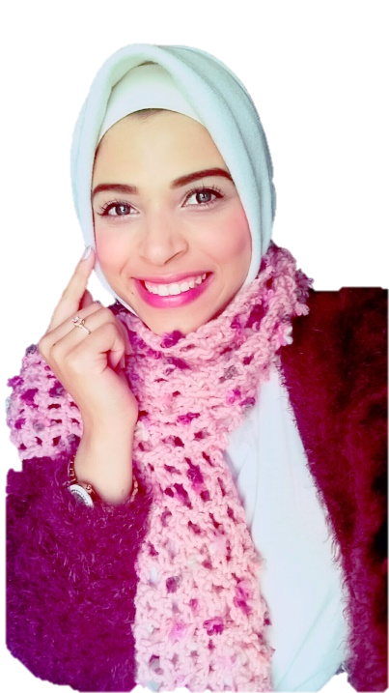Nourhan Khaled Sayed Hashem Ahmed

Mobile: 01204806402 – 01068130896

Email: [nourk6890@gmail.com](mailto:nourk6890@gmail.com)

Address: 10 Silem street end of faisl,Haram,Giza.

Date of Birth: 16/5/1997

Nationality: Egyptian.

Gender: Famale.

++فاا+فththTHTHTHTHTHMG666KK;L;L;;;766

Objective

Seeking a suitable position in well-established company where I can build upon and utilize my previous work experience,enhance my languge,computer,leadership and communication skills,fulfill my personal ambition and improve my knowledge.

ـــــــــــــــــــــــــــــــــــــــــــــــــــــــــــــــــــــــــــــــــــــــــــــــــــــــــ

Education

Bachelor of Arts,Department of Philosophy,Ain Shams University. May 2019

ــــــــــــــــــــــــــــــــــــــــــــــــــــــــــــــــــــــــــــــــــــــــــــــــــــــــــــ

Experiences

1-Sales at El Sewedy Company for lighting and Cables.

2-Markting social media in trast company.

3-Sales agent in chubb life insurance company.

4-Hr in chubb life insurance company.

5-sales in gig Egypt life takfel.

ــــــــــــــــــــــــــــــــــــــــــــــــــــــــــــــــــــــــــــــــــــــــــــــــــــــــــــــ

Courses

English August 2019

ــــــــــــــــــــــــــــــــــــــــــــــــــــــــــــــــــــــــــــــــــــــــــــــــــــــــــــــــ

Skills

Computer Skills

Microsoft office

New Techology

Art Skill

Drawing and Painting

Arts

Origami

Interests

Teaching

Exploration

The new techology

Photography

Sports