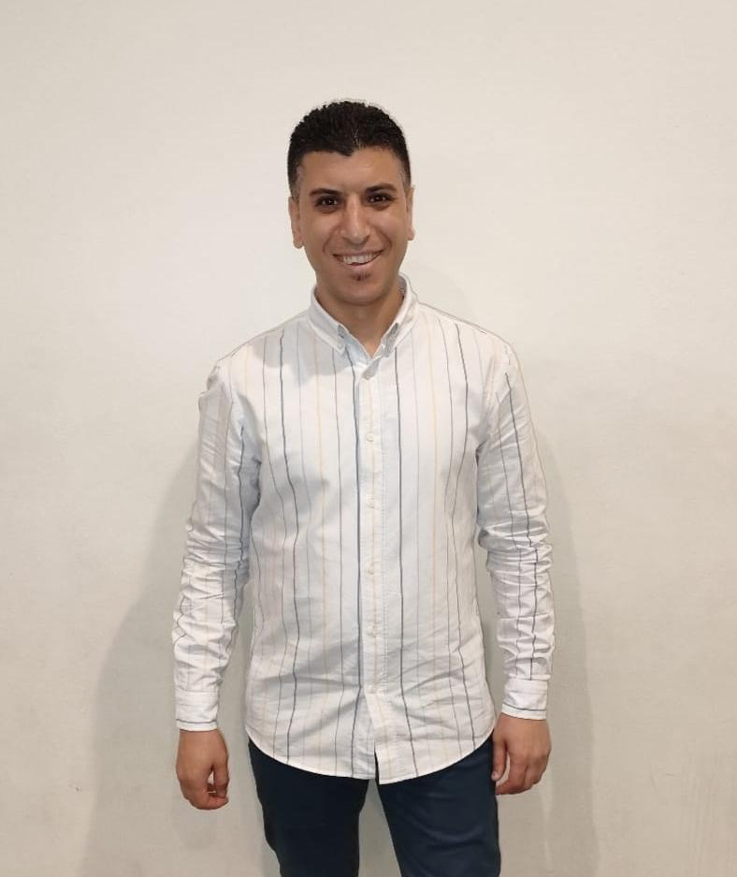

**Name : Wael Mohamed Farag**

**Date of Birth: – 24/12/1983**

**Email: w.mo.frag@gmail.com**

**Tel: – 01126466255**

|  |
| --- |
| ***CAREER OBJECTIVE*** |
| My top three objectives as a Retail Store Manager are 1) maximize the Brand profits; 2) increase team retention and reduce employee turnover; and 3) maintain great customer service.  To realize these, I will conduct an analysis of the competitor’s activity and pricing and align the company’s own in terms that are reasonable and acceptable; I will establish a positive and empowering environment where the team can work harmoniously with one another.  Lastly, I will ensure that customers are promptly and courteously attended to at all times.   |  | | --- | | ***SKILLS PROFILE*** | | * Highly experienced in managing retail stores & sales analyze * Deep knowledge of people management techniques * Exceptional knowledge of store standards * Skilled in conducting training of staff * Ability to supervise employees on daily basis to achieve sales target  |  | | --- | | ***EMPLOYMENT AND EXPERIENCE*** | | |  |  |  | | --- | --- | --- | | 1-erea manager | Retail group Egypt | January 2021 – Current | | 2- Store Manager    3- Store Manager  4- Store Manager | MONSOON & Accessorize  Mall off Arabia  MONSOON & Accessorize  City Stars    MONSOON & Accessorize  City Center maadi | July 2020 – January 2021  Septmber 2017 – July 2020    Jan 2016 –Sep 2017 | | * Implemented retail standards for the store. * Participated in store promotional activities to increase sales. * Prepared sales strategies based on market trends and competitors. * Conducted employee performance evaluations and provided appropriate feedbacks. * Maintained the store clean, organized and safe for customers. * Addressed customer queries and ensured customer satisfaction * Looked for commercial display and customer profile to encourage our sales * Ability to analyze sales and increase it by K.P.I's * Ability to make a strong team that can achieve the goals of the organization  |  |  |  | | --- | --- | --- | | Assistant store manager | MONSOON & Accessorize  City Center maadi | July 2014 – January 20216 |  * Worked with management to develop business plan and in-store promotions. * Ensured store administration operations are in accordance with due diligence guidelines. * Managed all store operations within assigned budget. * Conducted orientations and training sessions for store staffs. * Managed stock management, replenishment and rotation activities     Sales manager Hanz company forelevators. October 2011– July 2014  Sales manager EGTC GROUP Company JULY 2010 – September2011  Sales advicer Cairo international conference center May 2007 – February 2010   |  | | --- | | ***EDUCATIONAL BACKGROUND***  **Fucalty of low- Cairo University**  **Grade Good**  **Language:**  **ENGLISH acceptable**  **Others skills:**  **Microsoft**  **Excel , word, power point** | |  | | | | | | |